**Credit Risk Analysis**

**A PROJECT REPORT**

***submitted to***

**Rayalaseema University, Kurnool**

*in partial fulfillment of the requirements for the award of degree of* **BACHELOR OF TECHNOLOGY**

in

**COMPUTER SCIENCE AND ENGINEERING**

by

**DANDAATCHUTHKUMARREDDY [Reg.No.20RU1A0511]**

**METUKURU SATEESHREDDY [Reg. No.: 20RU1A0534]**

**KAIRUPPALA DEVESH [Reg. No.: 20RU1A0538]**

**JANKE VISHNU VARDHAN REDDY [Reg. No.: 20RU1A0520]**

Under the esteemed guidance of

**Sri. V.SATISH KUMAR M.Tech (Ph.D)**

Assistant Professor (Ad hoc)



**DEPARTMENT OF COMPUTER SCIENCE AND ENGINEERING RAYALASEEMA UNIVERSITY COLLEGE OF ENGINEERING [RAYALASEEMA UNIVERSITY, KURNOOL – 518 007, A.P., INDIA] JUNE – 2024**

RAYALASEEMA UNIVERSITY COLLEGE OF ENGINEERING

KURNOOL – 518007, Andhra Pradesh (INDIA)

**DEPARTMENT OF COMPUTER SCIENCE AND ENGINEERING CERTIFICATE**

This is to certify that the project work entitled CREDIT RISK ANALYSIS **DANDAATCHUTHKUMARREDDY [Reg. No.: 20RU1A0506]**

**METUKURU SATEESHREDDY [Reg.No.:20RU1A0533]**

**KAIRUPPALA DEVESH [Reg. No.: 20RU1A0522]**

**JANKE VISHNU VARDHAN REDDY[Reg.No.:20RU1A0520]**

and is being submitted to Rayalaseema University, Kurnool in partial fulfillment of the requirements for the award of degree of **BACHELOR OF TECHNOLOGY** in **COMPUTER SCIENCE AND ENGINEERING** during the academic year 2023-2024.

The results embodied in this project report have not been submitted to any other University or Institute for the award of any degree or diploma.

**Signature of Guide Signature of HOD**

**Smt. M.N.P.SWETHA PRIYA**

Assistant Professor (Ad hoc)

Dept. of CSE Rayalaseema University College of Engineering,

Kurnool – 518 007, A.P., India

**Sri. V.SATISH KUMAR**

Assistant Professor (Ad hoc) & Coordinator

Dept. of Computer Science and Engineering Rayalaseema University

College of Engineering, Kurnool – 518 007, A.P., India

**Submitted for university examination held on date ……………………………….**

**INTERNAL EXAMINER EXTERNAL EXAMINER**

**ACKNOWLEDGEMENT**

It is my privilege and pleasure to express my profound sense of respect, gratitude and indebtedness to my guide Smt.M.N.P.SwethaPriya**, M. Tech** Coordinator of Computer Science and Engineering, **Rayalaseema University College of Engineering, Kurnool.,** for his indefatigable inspiration, guidance, cogent discussion and encouragement throughout this dissertation work.

I am grateful to **Mr. V. Satish Kumar, M. Tech** Coordinator of Computer Science and Engineering for his support and uninterrupted cooperation during my seminar work.

I am deeply indebted to my Principal **Dr. Y. Hari Prasad Reddy, M. Tech, Phd** for his constant support and valuable guidance was a source of inspiration for me.

This Acknowledgement will be incomplete without mentioning my sincere gratefulness to our Honorable Vice Chancellor **Prof. B. Sudheer Prem kumar Garu,** who has been observed posing valiance in abundance, forwarding my individuality to acknowledge my project work tendentiously.

Finally, I wish to acknowledge **my friends, family members and colleagues** for giving moral strength and helping me to complete this dissertation

**By**

**D.ATCHUTHKUMAR (20RU1A0506)**

**K. DEVESH (20RU1A0513)**

**J. VISHNU VARDHAN REDDY (20RU1A0534)**

**M.SATEESHREDDY (20RU1A0538)**

**ABSTRACT**

We would like to express our sincere gratitude to everyone who contributed to the successful completion of this credit risk analysis project. Special thanks to [Project Supervisor's Name] for their invaluable guidance, expertise, and unwavering support throughout the project duration. We are also grateful to the entire team for their dedication and hard work in collecting, cleaning, and analyzing the data. Additionally, we extend our appreciation to [Financial Institution's Name] for providing access to the necessary resources and data for this study. This project would not have been possible without the collective effort and collaboration of all involved parties.

The aim of this project was to develop an advanced credit risk analysis framework using machine learning techniques to enhance risk assessment and decision-making in a financial institution. The project involved building and refining predictive models to assess the creditworthiness of borrowers and predict the likelihood of default. We utilized a comprehensive dataset comprising historical credit information and borrower attributes. Various machine learning algorithms, including logistic regression, random forest, and gradient boosting, were employed to develop robust credit scoring models. The models were evaluated based on performance metrics such as accuracy, precision, recall, and area under the receiver operating characteristic curve (AUC-ROC).

The results demonstrated a significant improvement in predictive accuracy compared to traditional scoring methods, leading to more informed credit decisions and reduced default rates. This project underscores the importance of leveraging data-driven approaches to enhance credit risk management and improve overall portfolio performance.

Table of Contents

Introduction 1

Project Overview 2

Objectives 3

Scope and Limitations 4

Background and Problem Statement 5

Credit Risk Overview 6

Importance Of Credit Risk Analysis 8

Problem Statement And Business Content 9

Data Science Life Cycle 11

Data Cleaning and Transformation 12

Handling Missing values and Outliers 14

Exploratory Data Analysis(EDA) 16

Descriptive Statistics 18

Data Science Process 20

Feature Engineering 21

Feature Selection 22

Encoding Categorical Variables 24

Handling Imbalanced Dataset 25

Statistical Analysis 27

Chi-Square Test For Categorical Variables 29

Variance Inflation Factor (VIF) Analysis 31

Analysis Of Variance (ANOVA) For Numerical Variables 33

Model Development 35

Model Training And Validation 39

Evaluation Metrics 41

Model Deployment 43

Development Of Flask Web Application 46

Hyperparameter Tuning 49

Grid Search For Model Optimization 51

Tuning XGBoost Parameters 52

Performance Improvement Analysis 54

Model Performance Comparision 55

Insights And Recommendations 56

Conclusion 57

Refernces 61

# Introduction

Credit risk modeling plays a critical role in the financial industry by providing institutions with the tools to assess and manage the risk associated with lending activities. The primary purpose of credit risk modeling is to evaluate the likelihood of default or non-payment by borrowers, thereby enabling lenders to make informed decisions about extending credit. This modeling process involves analyzing historical data, identifying risk factors, and developing predictive models that can estimate the probability of default for individual borrowers or portfolios of loans. By accurately assessing credit risk, financial institutions can optimize their loan pricing strategies, allocate capital efficiently, and mitigate potential losses.

The scope of credit risk modeling encompasses various types of credit instruments, including consumer loans, corporate loans, mortgages, and more. Models can be designed to assess different aspects of credit risk, such as default risk, credit spread risk, or counterparty risk. The methodology used in credit risk modeling often involves statistical techniques, machine learning algorithms, or a combination of both, depending on the complexity and volume of available data. Model validation is a crucial step to ensure the reliability and accuracy of the credit risk models, aligning with regulatory requirements and industry standards such as Basel regulations. Effective credit risk modeling not only supports sound risk management practices but also contributes to maintaining financial stability and sustaining healthy lending operations within the financial sector.

In addition to assessing credit risk for loan approvals and pricing, credit risk modeling plays a fundamental role in portfolio management and regulatory compliance. By implementing robust credit risk models, financial institutions can optimize their portfolio composition to achieve a balanced risk-return profile. These models enable proactive risk monitoring and early identification of deteriorating credit quality, allowing lenders to take timely actions to mitigate potential losses. Furthermore, credit risk modeling is essential for regulatory compliance, as it helps institutions meet the requirements set forth by regulatory bodies such as central banks or financial authorities. Through continuous refinement and validation, credit risk models evolve to adapt to changing market conditions and economic environments, enhancing their effectiveness in supporting prudent credit risk management practices across the financial industry.

## Project Overview

The project on credit risk modeling aims to develop robust predictive models that assess the creditworthiness of borrowers and quantify the risk associated with lending activities. In the dynamic landscape of financial institutions, effective credit risk modeling plays a pivotal role in optimizing loan approval processes, enhancing risk management strategies, and improving overall portfolio performance. This project addresses the critical need for accurate risk assessment by leveraging advanced statistical techniques and machine learning algorithms.

To achieve its objectives, the project will focus on several key components. Firstly, it involves comprehensive data collection from diverse sources to capture a wide range of borrower characteristics, credit history metrics, and financial indicators. This data will be preprocessed and cleaned to ensure its suitability for model development. Secondly, the project will undertake feature engineering to extract meaningful insights from the collected data, identifying relevant predictors of credit risk. This step is crucial for building robust and interpretable predictive models.

The core of the project lies in developing and evaluating machine learning models tailored for credit risk assessment. These models will leverage historical data to predict the likelihood of default, estimate potential losses in the event of default, and quantify overall exposure to credit risk. By implementing sophisticated modeling techniques, such as logistic regression, decision trees, random forests, and gradient boosting, the project aims to deliver accurate risk predictions that empower financial institutions to make informed lending decisions and optimize their credit risk management practices.

Furthermore, the project will emphasize the importance of model interpretability and transparency in credit risk assessment. The developed models will not only focus on predictive accuracy but also on providing actionable insights and explanations for their predictions. Interpretability is crucial for gaining stakeholders' trust and facilitating effective decision- making based on model outputs. Additionally, the project will evaluate the performance of different modeling approaches using appropriate evaluation metrics such as accuracy, precision, recall, and area under the ROC curve (AUC).

## Objectives

**Develop Predictive Models**: Create accurate and reliable predictive models using machine learning algorithms to assess the credit risk associated with individual borrowers or entities. These models will leverage historical data and borrower characteristics to estimate the probability of default and quantify credit risk exposure.

**Enhance Credit Decision-Making**: Improve the decision-making process for loan approvals and credit risk management by providing lenders with actionable insights derived from predictive models. The goal is to enable financial institutions to make informed and data-driven lending decisions, optimize risk-adjusted returns, and enhance portfolio performance

.

**Optimize Risk Management Strategies**: Implement effective risk management strategies based on credit risk modeling outputs. This includes setting risk thresholds, defining credit scoring criteria, and establishing risk mitigation measures to manage and mitigate credit risk across the loan portfolio.

**Improve Portfolio Performance**: Use credit risk modeling to optimize the allocation of resources and investments within the loan portfolio. By identifying high-risk borrowers and potential default scenarios early, financial institutions can proactively manage credit exposures and improve overall portfolio performance.

**Ensure Regulatory Compliance**: Ensure compliance with regulatory requirements and industry standards related to credit risk management. The project aims to develop models that align with regulatory guidelines and support responsible lending practices.

## Scope and Limitations

The credit risk modeling project is designed to develop sophisticated predictive models that assess and quantify credit risk within a lending portfolio. The project's scope encompasses multiple critical components of credit risk management:

Firstly, comprehensive data collection will be conducted to gather diverse information about borrowers, including demographics, credit history, financial metrics, and loan characteristics. This data will undergo rigorous preprocessing to ensure accuracy, completeness, and suitability for modeling purposes.

Secondly, feature engineering will be employed to extract meaningful insights from the collected data. This involves identifying relevant predictors of credit risk and transforming raw variables into informative features that can be utilized by predictive models.

Thirdly, the project will focus on building and evaluating machine learning models tailored for credit risk assessment. Various modeling techniques such as logistic regression, decision trees, random forests, and gradient boosting will be explored to predict the probability of default, estimate potential losses, and assess overall exposure to credit risk.

Lastly, model interpretability will be emphasized to provide stakeholders with actionable insights and explanations for credit risk predictions. This transparency is crucial for gaining trust in the model outputs and facilitating informed decision-making within financial institutions.

Despite the ambitious scope of the project, several limitations must be acknowledged and addressed:

**Data Quality and Availability**: The effectiveness of credit risk models heavily depends on the quality and availability of historical data. Incomplete or inaccurate data can undermine model performance and reliability.

**Regulatory Constraints**: Compliance with regulatory requirements and standards imposes constraints on data usage, model development, and deployment. Models must align with regulatory guidelines to ensure legal and ethical compliance.

## Background and Problem Statement

##### Background:

Credit risk analysis is a critical process within financial institutions that involves assessing the likelihood of borrowers defaulting on their loans or credit obligations. This analysis is vital for maintaining a healthy loan portfolio, managing financial risks, and ensuring the stability of financial institutions.

Financial institutions, such as banks, lending companies, and credit unions, are exposed to credit risk when they extend credit to individuals or businesses. The primary concern is that borrowers may not be able to fulfill their repayment obligations, leading to potential losses for the lender. Effective credit risk analysis involves evaluating various factors to estimate the probability of default and the potential severity of losses if default occurs.

##### Problem Statement :

The problem of credit risk analysis involves developing robust methodologies and models to assess and manage credit risk effectively. The goal is to make informed decisions about extending credit while minimizing potential losses due to defaults. Key aspects of the problem include:

1. Data Collection And Analysis 2.Decsion Making

1. Model development
2. Risk Assesment
3. Monitoring and Adaptation

The challenge of credit risk analysis involves leveraging data and advanced analytical techniques to make informed decisions about lending, while safeguarding financial institutions against potential losses associated with borrower defaults. The ultimate objective is to strike a balance between risk and reward in credit activities, thereby ensuring the long-term viability and stability of financial institutions.

# Credit Risk Overview

Credit risk is a fundamental aspect of financial risk management, encompassing the potential loss faced by lenders or investors when borrowers or counterparties fail to meet their debt obligations. This risk arises across various financial transactions, including loans, bond investments, and derivative contracts. Understanding and effectively managing credit risk are essential for maintaining the stability and profitability of financial institutions.

One key component of credit risk is default risk, which refers to the possibility that a borrower will be unable to make timely payments on their debt. This risk is assessed through metrics such as the Probability of Default (PD), which quantifies the likelihood of a borrower's default, and Loss Given Default (LGD), which measures the potential loss in the event of default. Additionally, credit risk includes factors like credit spread risk, credit migration risk, concentration risk, and country risk, each contributing to the overall exposure faced by lenders and investors.

Credit risk assessment involves thorough credit analysis, which includes evaluating a borrower's creditworthiness based on financial statements, credit scores, industry conditions, and economic outlook. Credit ratings provided by agencies like Moody's or Standard & Poor's are also crucial in assessing credit risk. These assessments help financial institutions determine appropriate lending terms, pricing, and risk management strategies.

To manage credit risk effectively, financial institutions employ various mitigation techniques. Diversification of credit exposures across different borrowers, sectors, and geographical regions helps reduce concentration risk. Collateralization and guarantees provide additional security against potential losses. Credit derivatives, such as credit default swaps (CDS), enable institutions to transfer credit risk to other parties. Regular monitoring and surveillance of credit portfolios allow for timely adjustments in risk exposures based on changing market conditions and borrower credit profiles.

Regulatory frameworks play a vital role in credit risk management, with financial regulators imposing guidelines and capital adequacy requirements on institutions to ensure they maintain prudent levels of credit risk exposure. Basel Accords, such as Basel II and Basel III, provide standardized approaches for assessing and managing credit risk, including capital requirements based on the riskiness of credit exposures. Compliance with these regulations helps promote stability and resilience within the financial system by encouraging sound credit risk practices. Overall, effective credit risk management is essential for safeguarding financial institutions against potential losses and maintaining confidence in the broader financial markets.

Credit risk refers to the potential loss that a lender or investor faces when a borrower or counterparty fails to make payments on debt obligations. It is a fundamental risk for financial institutions and other entities that extend credit or invest in debt securities. Understanding credit risk is crucial for assessing the overall risk profile of a loan portfolio, bond investment, or any credit exposure.

**Types of Credit Risk**:

**Default Risk**: The risk that a borrower will be unable to make required payments on their debt obligations.

**Credit Spread Risk**: The risk of adverse movements in credit spreads (the difference in yield between different types of bonds) affecting the value of investments.

**Credit Migration Risk**: The risk that the credit quality of a borrower deteriorates over time, leading to potential losses.

**Concentration Risk**: The risk arising from having a large exposure to a single borrower, sector, or geographical region.

**Country Risk**: The risk of economic, social, or political factors affecting a borrower's ability to repay debt.

## Importance Of Credit Risk Analysis

Credit risk analysis is of paramount importance for financial institutions and investors due to several key reasons. Firstly, it helps assess the creditworthiness of borrowers, enabling lenders to make informed decisions about extending credit and setting appropriate terms and conditions. Through detailed analysis of financial statements, credit scores, and industry trends, institutions can evaluate the likelihood of borrowers defaulting on their obligations. This assessment is crucial for pricing loans or bonds accurately, ensuring that the risk is commensurate with the potential return. By conducting thorough credit risk analysis, institutions can effectively manage their portfolios, optimizing risk-adjusted returns while minimizing potential losses.

Secondly, credit risk analysis is vital for maintaining the stability and solvency of financial institutions. By identifying and quantifying potential credit risks associated with borrowers and counterparties, institutions can implement risk mitigation strategies such as diversification, collateralization, or hedging through derivatives. This proactive approach helps protect institutions from unexpected losses arising from credit defaults or adverse market conditions. Additionally, effective credit risk analysis is essential for regulatory compliance, as financial regulators often require institutions to maintain adequate capital reserves based on the riskiness of their credit portfolios. Overall, robust credit risk analysis is critical for ensuring the soundness of financial institutions and fostering confidence in the broader financial system.

In addition to financial stability and transparency, effective credit risk analysis contributes to improved profitability and competitiveness for financial institutions. By accurately assessing credit risk, institutions can optimize their lending practices, targeting creditworthy borrowers and pricing loans appropriately to reflect the associated risk. This enables institutions to maximize returns on their credit portfolios while minimizing potential losses from defaults or credit impairments. Moreover, a strong credit risk analysis framework enhances risk-adjusted decision-making, allowing institutions to allocate resources efficiently and pursue growth opportunities that align with their risk appetite. Ultimately, integrating robust credit risk analysis into business strategies empowers institutions to navigate market uncertainties effectively and sustain long-term profitability.

## Problem Statement And Business Content

##### Problem Statement:

The problem at hand is to develop a robust credit decision model using data from Bank of Baroda to determine whether a loan should be granted to an individual applicant. This involves assessing the creditworthiness of applicants based on various factors and historical data to minimize the risk of default and optimize lending decisions.

##### Business Context:

Bank of Baroda aims to enhance its credit decision-making process by leveraging data analytics and machine learning. The objective is to streamline loan approval processes while minimizing the risk of default and improving overall portfolio performance. Key aspects of the business context include:

##### Customer Risk Assessment:

* Utilizing historical customer data, including credit scores, income levels, employment status, repayment history, and demographic information, to assess the credit risk associated with each applicant.
* Developing a scoring model that quantifies the likelihood of default based on these customer attributes.

##### . Loan Approval Optimization:

* Implementing a data-driven approach to optimize loan approval decisions, ensuring that credit is extended to deserving applicants while minimizing the risk of non-repayment.
* Setting appropriate credit limits and interest rates based on risk assessments to maximize profitability and minimize losses.

##### Compliance and Regulatory Requirements:

* Adhering to regulatory guidelines and internal policies to ensure responsible lending practices.
* Incorporating legal and regulatory considerations into the credit decision model to mitigate compliance risks.

##### Model Development and Validation:

* Building predictive models using statistical techniques and machine learning algorithms to forecast creditworthiness.
* Validating and fine-tuning models using historical loan performance data to improve accuracy and reliability.

##### Operational Efficiency:

* Enhancing operational efficiency by automating parts of the loan approval process using data-driven insights.
* Streamlining underwriting procedures to expedite loan decisions while maintaining risk management standards.

##### Portfolio Management :

* Monitoring loan portfolios in real-time to identify emerging risks and proactively adjust lending strategies.
* Implementing portfolio diversification strategies to spread risk and optimize returns.

##### Customer Experience Enhancement:

Leveraging data analytics to personalize the lending experience for customers, offering tailored loan products and services based on individual credit profiles and financial needs. Implementing user-friendly digital platforms and mobile applications for loan applications and approvals, enhancing customer convenience and accessibility. Providing transparent and clear communication about loan terms, interest rates, and repayment schedules to build trust and confidence among borrowers. Offering proactive financial guidance and support to borrowers, promoting responsible borrowing and improving overall financial literacy .By focusing on enhancing customer experience alongside optimizing credit decision- making processes, Bank of Baroda aims to establish itself as a customer-centric financial institution that prioritizes responsible lending practices and sustainable growth. This holistic approach not only mitigates credit risks but also fosters long-term customer loyalty and profitability, ultimately contributing to the bank's success in the competitive financial services industry. By addressing these business objectives, Bank of Baroda aims to improve the overall quality of its loan portfolio, reduce credit losses, and enhance customer satisfaction through timely and informed credit decisions.

# Data Science Life Cycle

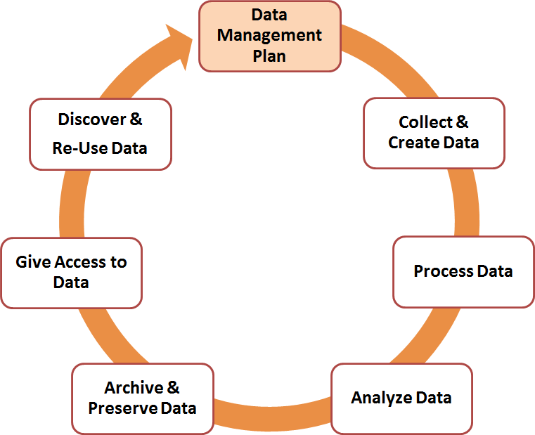

## Data Cleaning and Transformation

Data cleaning and transformation are critical stages in credit risk analysis, ensuring that the data used for modeling and decision-making is accurate, reliable, and suitable for analysis. In the context of credit risk analysis, these processes involve preparing raw data obtained from various sources, such as customer records, financial statements, and credit bureau reports, for use in predictive modeling and risk assessment. Here's how data cleaning and transformation are typically carried out

**Data Cleaning:**

**Handling Missing Values**: Identifying and addressing missing or incomplete data by either imputing values based on statistical methods (e.g., mean, median) or removing records with substantial missing information.

**Dealing with Outliers**: Detecting and treating outliers that could skew the analysis or modeling results. Outliers might be corrected, removed, or analyzed separately based on domain knowledge.

**Standardizing Data Formats**: Ensuring consistency in data formats (e.g., date formats, currency symbols) across different datasets to facilitate merging and analysis.

**Removing Duplicate Records**: Identifying and eliminating duplicate entries to maintain data integrity and avoid biases in analysis.

**Data Transformation**:

**Feature Engineering**: Creating new variables (features) based on existing data that could enhance the predictive power of credit risk models. This might involve calculating ratios, aggregating information, or encoding categorical variables.

**Scaling and Normalization**: Scaling numerical variables to a common scale (e.g., using min- max scaling or z-score normalization) to ensure that variables with different ranges contribute equally to the analysis.

**Handling Categorical Variables**: Encoding categorical variables into numerical representations (e.g., one-hot encoding) suitable for machine learning algorithms.

**Temporal Analysis**: Extracting relevant time-based features (e.g., age of credit history, payment patterns over time) that could influence credit risk assessment.

In credit risk analysis, the quality of data cleaning and transformation directly impacts the accuracy and reliability of predictive models used to assess creditworthiness and make informed lending decisions. Rigorous data preprocessing helps minimize biases, improve model performance, and enhance the overall effectiveness of risk management strategies. It also supports regulatory compliance by ensuring that data used for credit assessment meets privacy and security standards. Therefore, investing time and effort in data cleaning and transformation is crucial for generating actionable insights and maintaining trust in credit risk analysis processes**.**

## Handling Missing values and Outliers

Handling missing values is the major part of Exploratory data analysis. Missing values are replaced by different methods. Using mean, median, mode, Na, Imputation and other techniques.



The above code is used for checking how many null values in the dataset. The code will sum up the all null values in the dataset.

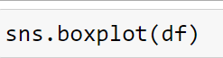

Boxplot was used for checking values which are outliers in the dataset.

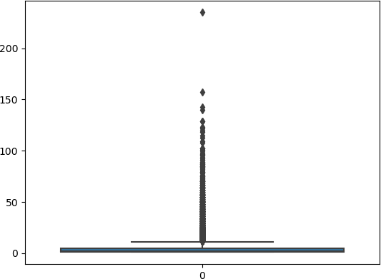

Here the black dotted values are outliers. outliers are misplaces the model so that’s why we replace outliers with mean, median, mode. It was done for the reason was model to predict accurately. By removing outliers model performance improves.

Mean, median and mode are central tendency measures. It was calculated by using Describe function.

df_encoded_unseen.describe()

The above used for to calculate all descriptive statistics such as mean, median, mode, standard deviation, count of values in the dataset, min, max, 25 %, 50 %, 75 %. These are also calculated by Boxplot also.

**Describe Function:**

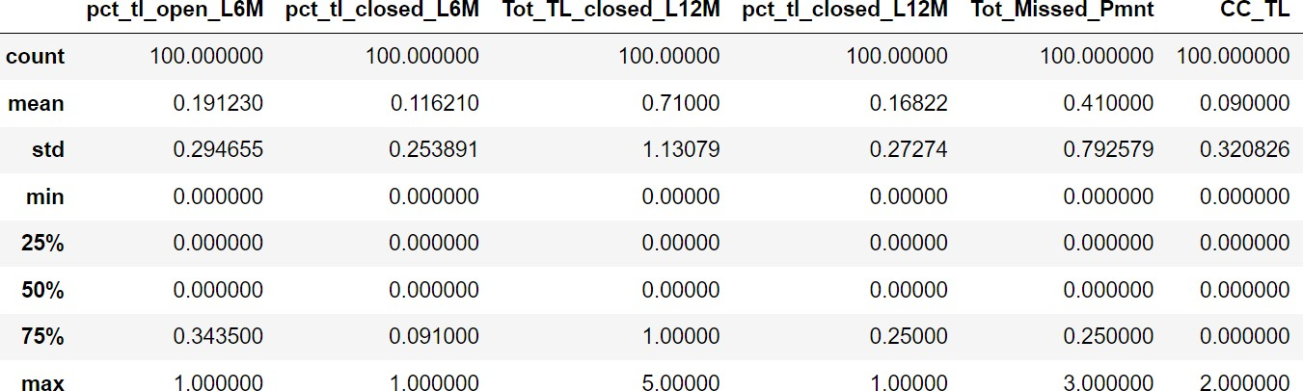

**Boxplot :**

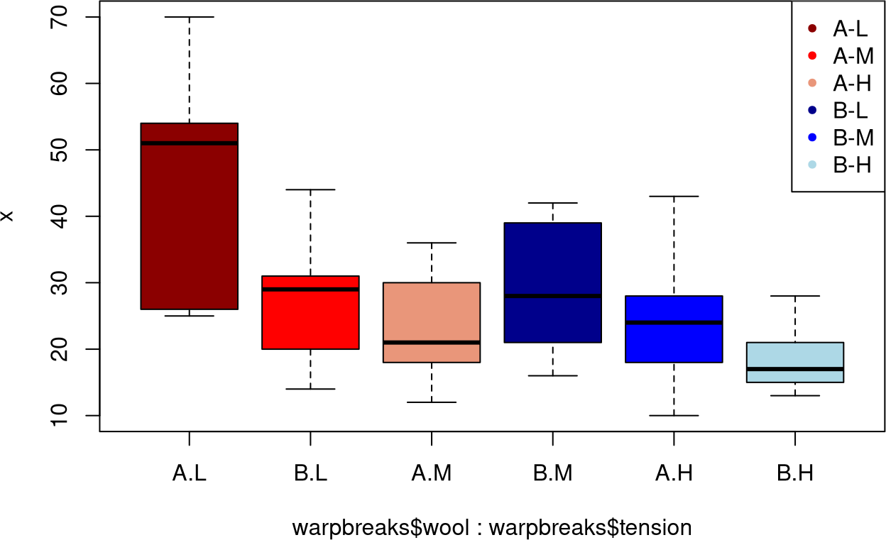

[This Photo](https://www.datascienceblog.net/post/data-visualization/boxplot/?ref=analisted) by Unknown Author is licensed under [CC BY-SA-NC](https://creativecommons.org/licenses/by-nc-sa/3.0/)

# Exploratory Data Analysis(EDA)

Exploratory Data Analysis (EDA) plays a crucial role in credit risk analysis by helping to understand and prepare the data before building predictive models. Here are key steps and considerations for conducting EDA in the context of credit risk analysis:

##### Data Collection and Understanding:

* Obtain the credit dataset, including information on borrowers, loans, credit scores, income levels, employment status, debt-to-income ratios, loan amounts, loan terms, and any other relevant variables.
* Understand the meaning and distribution of each variable in the dataset.

##### Data Cleaning:

* Handle missing values appropriately (e.g., imputation, deletion) to ensure data quality.
* Check for duplicates and remove them if necessary.
* Identify and address outliers that may impact the analysis.

##### Univariate Analysis:

* Examine the distribution of individual variables. For instance:
  + Plot histograms for numerical variables to understand their spread.
  + Use bar plots for categorical variables to visualize frequency distributions.
* Identify potential issues like skewness, heavy tails, or unusual patterns.

##### Bivariate and Multivariate Analysis:

* Explore relationships between variables to uncover insights:
  + Use scatter plots to visualize relationships between pairs of numerical variables.
  + Create pivot tables or cross-tabulations for categorical variables against the target variable (e.g., loan default status).
  + Compute correlation coefficients to quantify relationships between numerical variables.
* Identify important variables that are strongly correlated with credit risk.

##### Target Variable Analysis:

* Analyze the distribution of the target variable (e.g., loan default status):
  + Calculate the default rate and understand class imbalances.
  + Compare the characteristics of defaulted vs. non-defaulted loans across different variables.

##### Feature Engineering:

* + Create new features based on domain knowledge or insights gained during EDA. For example:
  + Derive ratios like debt-to-income ratio, loan-to-income ratio, etc.
  + Encode categorical variables appropriately (e.g., one-hot encoding, label encoding).

##### Visualization and Summary:

* Use visualizations (e.g., box plots, violin plots, heatmaps) to summarize findings and highlight patterns.
* Document key observations, insights, and hypotheses generated during EDA.

##### Statistical Tests :

* Conduct statistical tests (e.g., t-tests, chi-square tests) to validate assumptions or test hypotheses related to credit risk factors.

##### Model Preparation:

* Select appropriate features based on EDA findings.
* Handle any remaining data preprocessing tasks (e.g., scaling, encoding).
* Split the dataset into training, validation, and test sets for model development.

By performing comprehensive EDA, data scientists and analysts can gain a deeper understanding of the credit risk dataset, identify potential challenges or biases, and lay the groundwork for building accurate and robust credit risk models. EDA is essential for informed decision-making and ensuring the reliability of predictive models in credit risk analysis.

## Descriptive Statistics

Descriptive statistics are fundamental in credit risk analysis as they provide a clear summary and insight into the characteristics of the data related to borrowers, loans, and associated risk factors. These statistics help in understanding the distribution, central tendency, and variability of key variables, which is critical for making informed decisions and developing effective credit risk models. Here are some important descriptive statistics commonly used in credit risk analysis:

##### Central Tendency Measures:

**Mean**: The average value of a variable. For example, the mean loan amount or mean credit score of borrowers.

**Median**: The middle value when all values are sorted. It is less sensitive to outliers compared to the mean and provides insight into the typical value of a variable.

**Mode**: The most frequently occurring value in a dataset. Useful for understanding the most common categories within categorical variables.

##### Dispersion Measures:

**Standard Deviation**: Indicates the spread of values around the mean. Higher standard deviation implies greater variability.

**Variance**: The average of the squared differences from the mean. It quantifies the amount of variation or dispersion in a dataset.

**Range**: The difference between the maximum and minimum values of a variable. Provides a sense of the data spread.

**Interquartile Range (IQR)**: The range between the 25th and 75th percentiles. It is less affected by outliers compared to the range.

##### Distribution Characteristics:

**Skewness**: Measures the asymmetry of the distribution. Positive skewness indicates a longer right tail, while negative skewness indicates a longer left tail.

**Kurtosis**: Measures the peakedness of the distribution. Higher kurtosis indicates a sharper peak (leptokurtic), while lower kurtosis indicates a flatter distribution (platykurtic).

##### Quantiles and Percentiles:

**Percentiles**: Values below which a certain percentage of observations fall. For example, the 25th percentile (first quartile) and 75th percentile (third quartile) provide insights into the spread of data.

**Deciles**: Values that divide the data into 10 equal parts.

**Quartiles**: Values that divide the data into four equal parts.

##### Frequency Distribution:

**Histograms**: Display the distribution of numerical variables through bins or intervals.

**Bar Charts**: Show the frequency of categorical variables by category.

##### Correlation and Covariance:

**Correlation**: Measures the strength and direction of a linear relationship between two variables (e.g., correlation between credit score and default rate).

**Covariance**: Measures how two variables vary together. Positive covariance indicates that higher values of one variable correspond to higher values of the other (and vice versa for negative covariance).

**Correlation Coefficients**: Measure the strength and direction of linear relationships between pairs of numerical variables (e.g., credit score and loan default status). Positive correlation suggests that as one variable increases, the other tends to increase (and vice versa for negative correlation).

Descriptive statistics provide valuable insights into the risk profile of borrowers and loans, helping stakeholders (such as credit analysts and risk managers) understand key metrics and trends. They serve as the foundation for more advanced analyses and modeling techniques used in credit risk assessment and management.

Descriptive statistics help analysts and lenders understand the distribution, variability, and relationships within credit datasets, enabling better risk assessment and decision-making. They provide a foundation for more advanced analyses and modeling techniques in credit risk management

## Data Science Process

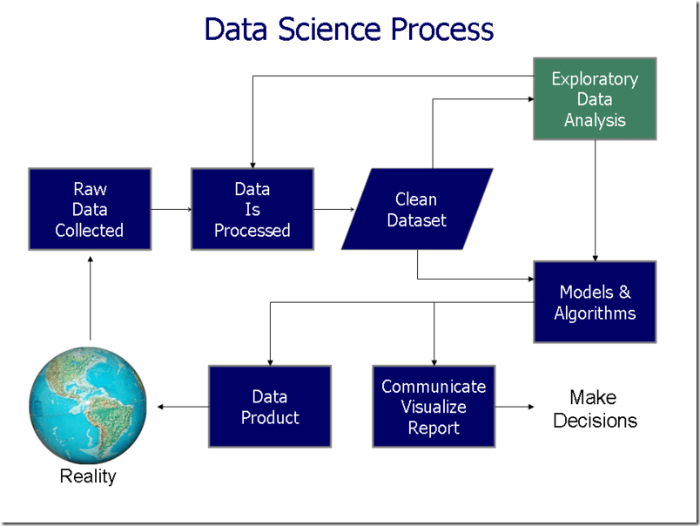

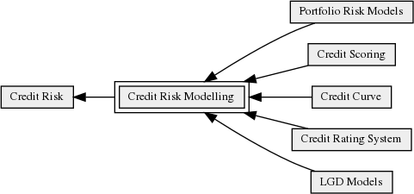

# Feature Engineering

Feature engineering is a pivotal aspect of credit risk analysis, aiming to extract valuable insights from raw data to enhance the predictive capabilities of machine learning models. One fundamental step involves data cleaning and handling missing values, where techniques such as mean, median, or mode imputation are applied to ensure data completeness. This process is crucial as it helps maintain the integrity of the dataset and provides a solid foundation for subsequent analysis.

Temporal features play a significant role in credit risk assessment, reflecting the age and stability of credit accounts. Metrics like the age of the oldest and newest credit lines (e.g.,

'Age_Oldest_TL’, ‘Age_Newest_TL’) are computed to capture credit history and assess borrowers' financial behaviors over time. Payment history indicators, such as missed payment flags (‘Tot_Missed_Pmnt’, ‘max_recent_level_of_deliq’), are also derived to evaluate borrowers' reliability in meeting their financial obligations.

Credit utilization features are essential in understanding borrowers' debt management practices. Ratios like `pct_tl_open_L6M` and `pct_tl_closed_L6M` are calculated to gauge credit card utilization, providing insights into borrowers' overall financial health. Additionally, derived ratios such as the debt-to-income ratio (`debt_to_income_ratio`) are computed by comparing total debt (e.g., `Tot_TL_closed_L12M`, `PL_TL`) to income (`NETMONTHLYINCOME`), offering valuable information about borrowers' capacity to manage debt.

Categorical encoding techniques are applied to transform non-numeric variables like

`MARITALSTATUS`, `GENDER`, and `last_prod_enq2` into binary indicators using one-hot encoding. This process enables machine learning models to effectively interpret categorical data and uncover patterns that influence credit risk. Interaction features are also constructed to capture synergies between different variables, providing a deeper understanding of complex relationships within the dataset.

In summary, feature engineering in credit risk analysis involves a series of sophisticated techniques to preprocess and transform raw data into actionable insights. By integrating temporal indicators, payment history metrics, credit utilization features, categorical encoding, and interaction features, machine learning models can leverage comprehensive information .

## Feature Selection

Feature selection is a critical step in credit risk analysis aimed at identifying the most relevant subset of features that contribute significantly to model performance while reducing complexity and overfitting. Effective feature selection not only improves model interpretability but also enhances prediction accuracy and efficiency. Here are key approaches to feature selection in the context of credit risk analysis:

##### Univariate Feature Selection:

This method involves selecting features based on univariate statistical tests, such as chi-square test for categorical variables and ANOVA F-test for numerical variables. By evaluating the statistical significance of each feature independently with respect to the target variable (`Approved_Flag`), irrelevant or less informative features can be filtered out.

##### Feature Importance from Tree-based Models:

Tree-based models like Random Forest or Gradient Boosting Machines (GBM) inherently provide feature importances. Leveraging these importances, you can select top-ranked features based on their contribution to model accuracy. Features with higher importance scores are likely more influential in predicting credit risk.

##### Correlation Analysis:

Identifying and removing highly correlated features can mitigate multicollinearity issues and improve model stability. Features that are strongly correlated with each other may redundantly convey similar information, leading to model inefficiencies.

##### Recursive Feature Elimination (RFE):

RFE is an iterative method that recursively removes less important features based on model performance. Starting with the full feature set, RFE eliminates features with the least significance until the desired number of features is reached. This approach is effective for selecting features based on their contribution to model accuracy

##### Domain Knowledge and Business Insights :

Collaborating with domain experts to understand the impact of different features on credit risk can provide valuable insights for feature selection. Domain knowledge can help prioritize features that are most relevant and aligned with business objectives.

##### L1 Regularization:

L1 regularization applies penalty to the absolute size of regression coefficients, encouraging sparsity in the feature space. As a result, less important features are assigned zero coefficients, facilitating automatic feature selection.

By applying these feature selection techniques, you can streamline the model training process, reduce overfitting, and build more interpretable credit risk models. It's essential to experiment with various methods and evaluate their impact on model performance through cross-validation to ensure optimal feature selection for your specific credit risk analysis task.

Additionally, feature selection in credit risk analysis should prioritize interpretability and domain relevance. It's important to strike a balance between model complexity and performance by selecting features that align with domain expertise and regulatory requirements. For instance, regulatory compliance may necessitate the inclusion of specific features related to credit history, income stability, or loan types. Domain experts can provide insights into which features are most meaningful for assessing credit risk and should be retained in the model. By leveraging a combination of statistical methods, model-based approaches, and domain knowledge, feature selection can enhance the transparency and effectiveness of credit risk models, ultimately supporting informed decision-making in lending and financial risk management. Regular validation and monitoring of selected features' impact on model performance and business outcomes are essential for maintaining the relevance and reliability of credit risk models over time.

## Encoding Categorical Variables

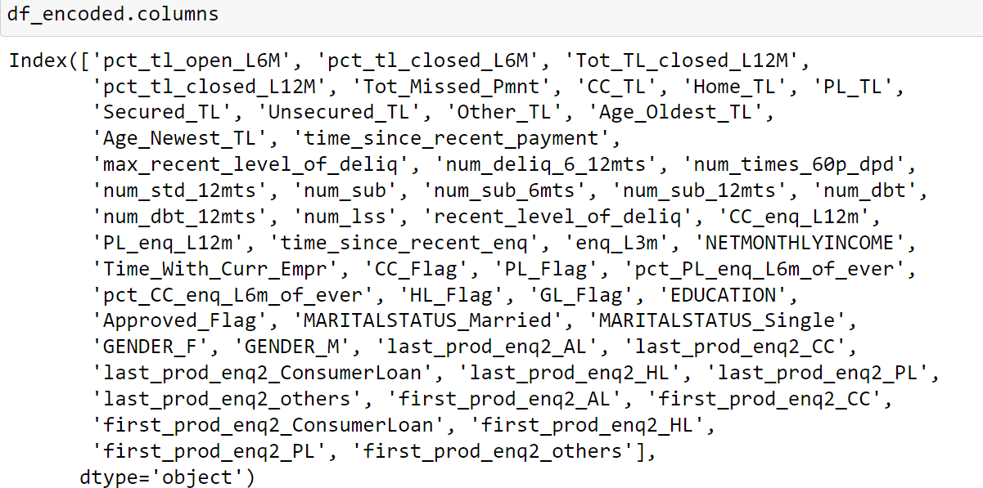

Image after encoding categorical variables.

These are categorical variables which requires encoding .Encoding is different types

* 1. Label Encoding 2. One hot encoding 3. Creating dummy variables

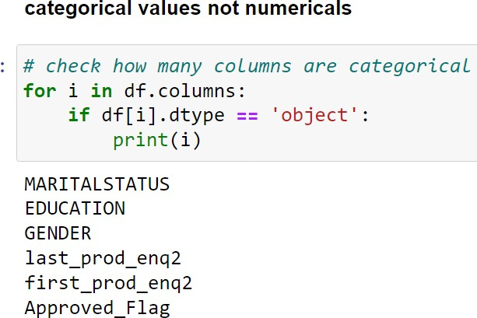

## Handling Imbalanced Dataset

Handling an imbalanced dataset is crucial in credit risk analysis, where the occurrence of default (positive class) is often much less frequent compared to non-default (negative class) cases. Imbalanced datasets can lead to biased model training, where the model may have a strong tendency to predict the majority class, resulting in poor performance on the minority class. Here are effective strategies for handling imbalanced datasets in credit risk analysis:

**Resampling Techniques**:

**Over-sampling Minority Class**: Increase the number of samples in the minority class by duplicating existing samples (e.g., SMOTE - Synthetic Minority Over-sampling Technique) to balance the class distribution.

**Under-sampling Majority Class**: Reduce the number of samples in the majority class by randomly removing instances to achieve a more balanced dataset.

**Class Weighting**:

* Assign higher weights to samples from the minority class during model training. Many machine learning algorithms allow setting class weights inversely proportional to class frequencies, ensuring that the model pays more attention to the minority class.

**Ensemble Techniques**:

* Use ensemble methods like Random Forest or Gradient Boosting Machines (GBM) that naturally handle class imbalance by aggregating predictions from multiple base learners trained on balanced subsets of data.

**Cost-sensitive Learning**:

* Introduce a cost matrix that penalizes misclassifications of the minority class more than the majority class. This approach explicitly incorporates the costs associated with false positives and false negatives into the model training process.

**Threshold Adjustment**:

* Modify the decision threshold of the classifier to achieve a desired balance between precision and recall. Lowering the threshold can increase sensitivity to the minority class at the expense of higher false positives.

**Anamoly Detection** - Treat credit risk prediction as an anomaly detection problem and leverage techniques like Isolation Forest or One-Class SVM to identify rare instances (e.g., defaults) based on their deviation from the norm.

**Evaluate Using Appropriate Metrics:**

* Instead of accuracy, use evaluation metrics such as precision, recall, F1-score, or Area Under the ROC Curve (AUC-ROC) that provide a more comprehensive view of model performance on imbalanced datasets.

By applying these strategies, you can mitigate the challenges posed by imbalanced datasets in credit risk analysis and build robust models that effectively identify and predict credit defaults while minimizing false predictions and bias towards the majority class. Experimentation with different techniques and careful evaluation of model performance are key to selecting the most suitable approach for addressing class imbalance based on the specific characteristics of your dataset and business requirements.

Furthermore, it's important to consider the business context and the implications of misclassification when handling imbalanced datasets in credit risk analysis. In financial settings, the cost associated with misclassifying credit defaulters (false negatives) can be significantly higher than misclassifying non-defaulters (false positives). Therefore, optimizing the model to minimize false negatives (i.e., accurately predicting defaults) while controlling for false positives is critical. This requires a nuanced approach that balances the sensitivity towards the minority class with the overall accuracy and business impact of model predictions.

Regular monitoring and updating of the model performance are essential when dealing with imbalanced datasets in credit risk analysis. As the underlying distribution of credit behaviors evolves over time, the model's effectiveness may diminish. Continuous evaluation of model metrics and validation against new data are necessary to ensure that the model remains robust and aligned with changing business conditions. Periodic retraining of the model with updated datasets and reevaluation of feature importance can further enhance its predictive capabilities and adaptability to shifting credit risk dynamics.

In summary, handling imbalanced datasets in credit risk analysis requires a combination of advanced modeling techniques, thoughtful feature engineering, and close collaboration between data scientists and domain experts. By leveraging resampling methods, class weighting, ensemble techniques, and strategic threshold adjustments, you can develop models that accurately capture credit risk signals while mitigating bias towards the majority class. It's imperative to select the appropriate strategy based on the specific characteristics of the dataset and business objectives, ensuring that the model's predictions are not only accurate but also actionable for effective risk management and decision-making in the financial sector. Regular monitoring and refinement of the model are key to maintaining its relevance and effectiveness over time.

# Statistical Analysis

Statistical analysis plays a crucial role in credit risk assessment, providing quantitative insights into the relationship between various factors and the likelihood of default. This analysis involves applying statistical methods to identify patterns, correlations, and predictive relationships within credit-related data. By leveraging statistical techniques, financial institutions can make informed decisions about lending practices, risk mitigation strategies, and portfolio management. Here are key aspects of statistical analysis in credit risk assessment.

**Descriptive Statistics**: Descriptive statistics such as mean, median, mode, standard deviation, and range are used to summarize and interpret key characteristics of credit-related variables. These measures provide insights into the central tendency, dispersion, and distribution of variables like income, debt levels, credit utilization, and payment history. Descriptive statistics help in understanding the overall profile of borrowers and identifying potential risk factors.

**Correlation Analysis:** Correlation analysis assesses the strength and direction of linear relationships between pairs of variables. By calculating correlation coefficients (e.g., Pearson's correlation coefficient), analysts can determine whether and how variables like credit scores, debt-to-income ratios, or loan amounts are associated with credit risk. Positive correlations indicate that as one variable increases, the other tends to increase (or decrease), while negative correlations imply an inverse relationship.

**Hypothesis Testing**: Hypothesis testing allows analysts to evaluate whether observed differences or relationships in the data are statistically significant or due to random chance. Common tests used in credit risk analysis include t-tests, chi-square tests, and ANOVA. For example, hypothesis testing can be used to determine if there are significant differences in credit scores between defaulters and non-defaulters.

**Predictive Modeling**: Statistical modeling techniques such as logistic regression, decision trees, and survival analysis are employed to build predictive models for credit risk assessment. These models leverage historical data to predict the likelihood of credit default based on borrower characteristics and credit-related variables. Statistical modeling enables quantification of risk factors, development of risk scoring systems, and estimation of default probabilities, supporting effective risk management strategies.

In conclusion, statistical analysis is essential for gaining deeper insights into credit risk dynamics and informing risk management decisions in the financial industry. By leveraging descriptive statistics, correlation analysis, hypothesis testing, and predictive modeling, analysts can uncover meaningful patterns in credit data, assess relationships between variables, and develop robust models for credit risk assessment.

In credit risk analysis, statistical analysis also involves assessing the performance of predictive models through metrics like accuracy, precision, recall, F1-score, and Area Under the ROC Curve (AUC-ROC). These metrics provide quantitative measures of model effectiveness in correctly identifying credit defaults and non-defaults. For instance, accuracy measures the overall correctness of predictions, while precision and recall focus on the model's ability to identify true positives (defaults) and avoid false positives (misclassifications). The AUC-ROC curve evaluates the trade-off between true positive rate and false positive rate across different classification thresholds, providing a comprehensive view of model performance.

Moreover, statistical analysis enables the development of risk scoring systems that assign credit scores or probabilities of default based on statistical models. These risk scores assist lenders in assessing the creditworthiness of borrowers and making informed decisions about loan approvals and interest rates. By quantifying credit risk using statistical methods, financial institutions can optimize portfolio management strategies, allocate resources effectively, and implement risk-based pricing policies.

Another important aspect of statistical analysis in credit risk assessment is stress testing and scenario analysis. These techniques involve simulating adverse economic conditions or unexpected events to evaluate the resilience of credit portfolios and assess potential losses under various scenarios. Statistical models are used to estimate the impact of adverse scenarios on key risk indicators such as default rates, loss severity, and credit losses. Stress testing provides valuable insights into the vulnerability of credit portfolios and helps institutions prepare for potential risks and uncertainties in the financial environment.

In summary, statistical analysis is integral to credit risk assessment, enabling financial institutions to leverage data-driven insights for effective risk management. By applying descriptive statistics, correlation analysis, predictive modeling, and performance evaluation metrics, analysts can identify risk factors, develop robust models, and implement proactive risk mitigation strategies. optimizing credit underwriting, and ensuring the stability and resilience of credit portfolios in dynamic and challenging market conditions.

## Chi-Square Test For Categorical Variables

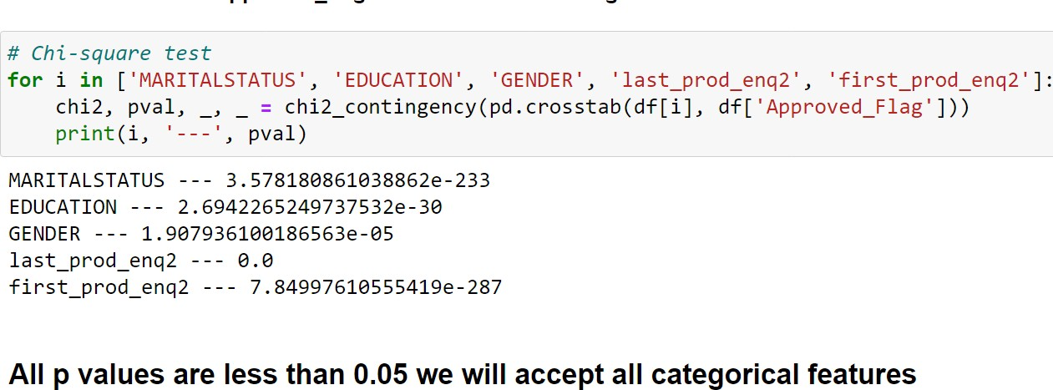

The features listed above represent a comprehensive set of variables used in credit risk modeling and assessment. To apply a chi-square test for categorical variables in this context, we need to identify which features are categorical and how they relate to the target variable, which appears to be the "Approved_Flag" representing different priority levels.

Here's a step-by-step approach to conducting a chi-square test for categorical variables in the context of this project:

##### Identify Categorical Variables:

Review each feature to identify categorical variables among the listed ones. Categorical variables typically include Marital Status (`MARITALSTATUS`), Education Level (`EDUCATION`), Gender (`GENDER`), Credit Card Flag (`CC_Flag`), Personal Loan Flag (`PL_Flag`), Housing Loan Flag (`HL_Flag`), Gold Loan Flag (`GL_Flag`), and product- related inquiries (`last_prod_enq2`, `first_prod_enq2`).

##### Formulate Contingency Tables:

For each identified categorical variable, create a contingency table that cross-tabulates the variable against the target variable (`Approved_Flag`). This table will show the frequency distribution of each category within the variable relative to the priority levels.

##### Compute Chi-Square Statistic:

Use the `chi2_contingency` function from `scipy.stats` to compute the chi-square statistic and associated p-value for each contingency table. This test will determine whether there is a

significant association between the categorical variable and the target variable (`Approved_Flag`).

**Interpret Results**: Examine the computed p-values to determine the statistical significance of each categorical variable in relation to credit risk assessment. A low p-value (typically less than 0.05) indicates that the categorical variable is significantly associated with the target variable and can potentially be used as a predictor in credit risk models.

**Make Inferences**: Based on the chi-square test results, draw conclusions about which categorical variables exhibit a significant relationship with credit risk levels. These insights will inform feature selection and model development, contributing to more accurate and interpretable credit risk assessments.

By following these steps, you can effectively leverage the chi-square test to analyze and validate the predictive value of categorical variables in credit risk modeling, thereby enhancing the robustness and reliability of the developed models.

In credit risk modeling, the chi-square test serves as a fundamental statistical tool to assess the dependency or independence between categorical variables and the target variable, which in this case is the "Approved_Flag" representing different priority levels. By applying the chi- square test, we aim to identify which categorical features have a statistically significant impact on credit risk assessment. This approach helps in understanding the relationships between different customer attributes and the likelihood of credit approval or risk classification.

The interpretation of the chi-square test results provides valuable insights into the predictive power of categorical variables within the credit risk modeling framework. A low p-value (< 0.05) obtained from the chi-square test indicates that the observed frequencies in the contingency table are unlikely to have occurred by chance alone. This statistical significance suggests that the categorical variable is informative and contributes meaningfully to predicting credit risk levels.

Furthermore, the chi-square test allows us to prioritize and select the most influential categorical variables for inclusion in credit risk models. Variables that exhibit a strong association with credit risk levels can be leveraged to build more accurate and effective models for risk assessment and decision-making. By focusing on relevant categorical features identified through rigorous statistical testing, credit risk analysts can optimize model performance and enhance the overall effectiveness of credit risk management strategies.

## Variance Inflation Factor (VIF) Analysis

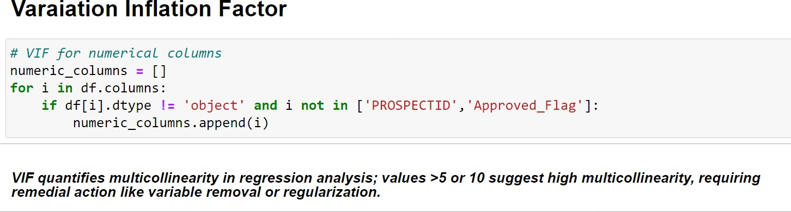

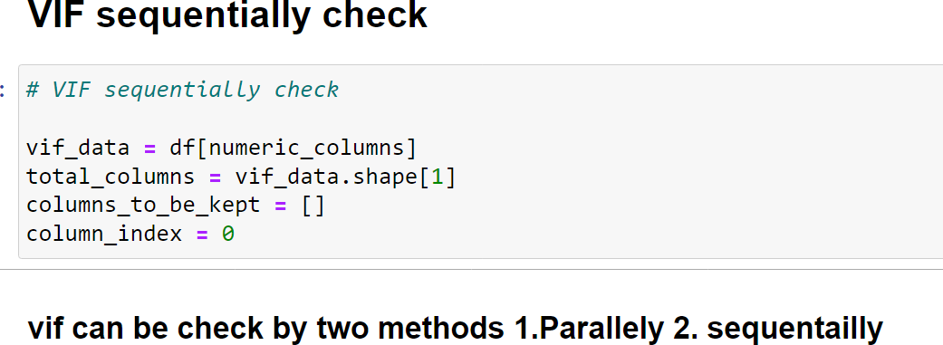

The Variance Inflation Factor (VIF) analysis is a statistical method used to assess multicollinearity among predictor variables in regression analysis, including credit risk modeling. Multicollinearity occurs when independent variables in a regression model are highly correlated with each other, which can lead to inflated standard errors and unreliable coefficient estimates. VIF helps to identify and quantify the extent of multicollinearity among predictor variables.

Here's how VIF analysis is applied in the context of credit risk modeling:

##### Calculation of VIF:

For each predictor variable in the model, calculate its VIF score. The VIF for a variable is calculated as \( VIF = \frac{1}{1 - R^2} \), where \( R^2 \) is the coefficient of

determination obtained from regressing the variable against all other predictor variables.

**Interpretation of VIF Scores**: A VIF score greater than 5 or 10 indicates a high level of multicollinearity, suggesting that the variable is strongly correlated with other predictors in the model. A high VIF score implies that the variance of the coefficient estimates is inflated, leading to unreliable interpretations of the variable's impact on the dependent variable (e.g., credit risk).

**Handling Multicollinearity**: If multicollinearity is detected (i.e., high VIF scores), consider several strategies to address it:

**Feature Selection**: Remove highly correlated variables from the model to reduce redundancy and improve model stability.

**Principal Component Analysis (PCA)**: Transform correlated variables into a smaller set of uncorrelated principal components.

**Regularization Techniques**: Apply regularization methods (e.g., Lasso, Ridge regression) that penalize large coefficients and mitigate the impact of multicollinearity.

##### Impact on Credit Risk Modeling:

In credit risk modeling, managing multicollinearity is crucial for building robust and interpretable models. By assessing VIF scores and addressing multicollinearity issues, analysts can enhance the reliability and predictive performance of credit risk models. This process ensures that the model accurately captures the unique contribution of each predictor variable to credit risk assessment, facilitating more informed lending decisions and risk management strategies.

In summary, VIF analysis plays a vital role in identifying and mitigating multicollinearity issues within credit risk modeling. By evaluating VIF scores and implementing appropriate strategies to address multicollinearity, analysts can optimize model performance and ensure the integrity of credit risk assessments, ultimately supporting sound decision-making in lending and financial risk management contexts.

## Analysis Of Variance (ANOVA) For Numerical Variables

Analysis of Variance (ANOVA) for numerical variables is a statistical method used to assess the significance of differences in means among two or more groups. In the context of credit risk modeling, ANOVA can be applied to understand how numerical predictor variables (features) contribute to explaining variations in the target variable (e.g., credit risk levels). Here's how ANOVA is typically conducted for numerical variables in this context:

##### Formulation of Hypotheses:

ANOVA tests whether there are statistically significant differences in the means of a numerical variable across different categories or groups. The null hypothesis (H0) states that the means of the groups are equal, while the alternative hypothesis (Ha) suggests that at least one group mean is different.

##### Selection of Predictor Variables:

Choose the numerical variables (features) that are hypothesized to influence credit risk levels or other target outcomes. These variables should have meaningful variations across different categories or levels.

##### Grouping of Data:

Categorize the data based on a relevant categorical variable (e.g., credit risk categories, loan types) that divides the dataset into distinct groups. This categorical variable serves as the independent variable in the ANOVA analysis.

##### Conducting ANOVA Test:

Perform ANOVA using statistical software or libraries. The analysis will provide an F-statistic and a p-value. The F-statistic measures the ratio of variance between groups to variance within groups. The p-value indicates the significance level of the test.

##### Interpreting Results:

If the p-value is below a predetermined significance level (commonly 0.05), the null hypothesis is rejected, suggesting that at least one group mean is significantly different from others. Post-hoc tests (e.g., Tukey's HSD, Bonferroni) may be conducted to identify specific group differences if the overall ANOVA result is significant.

##### Impact on Credit Risk Modeling:

ANOVA helps identify which numerical variables (such as age, income, delinquency metrics) significantly affect credit risk levels. Understanding these relationships enables modelers to prioritize important features, refine predictive models, and develop risk assessment strategies that account for variations in customer profiles or loan characteristics.

In summary, ANOVA for numerical variables is a valuable tool in credit risk modeling for identifying significant differences in means across categorical groups. By leveraging ANOVA, analysts can gain insights into the impact of numerical features on credit risk outcomes and refine predictive models to enhance risk assessment and decision-making processes in lending and financial services.

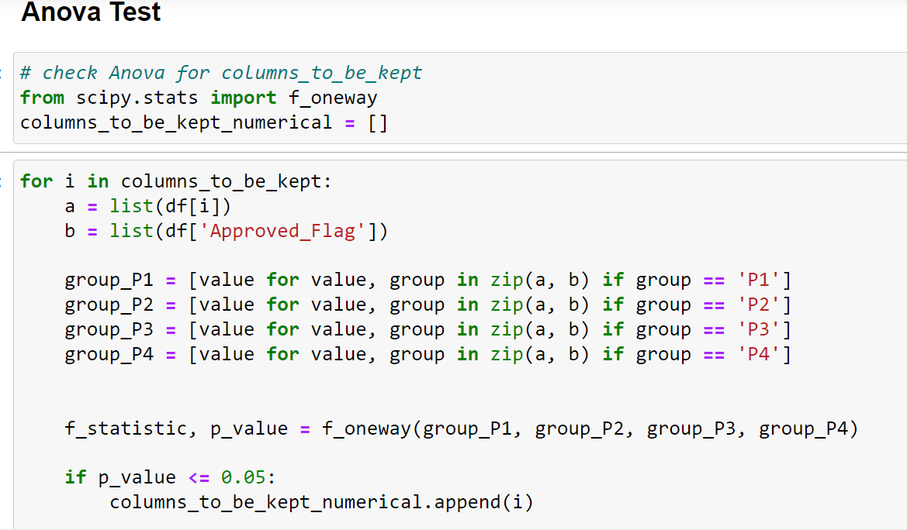

# Model Development

The provided code snippet outlines the development of machine learning models for credit risk assessment using the XGBoost algorithm. Here's a summary of the key steps and insights:

##### Data Preparation:

**Loading and Cleaning Data**:

The code loads data from two Excel files (`case_study1.xlsx` and `case_study2.xlsx`) into Pandas DataFrames (`df1` and `df2`). Rows with placeholder values like `-99999` are removed to ensure data quality.

##### Merging Dataframes:

The cleaned dataframes are merged using an inner join operation on a common identifier (`'PROSPECTID'`), creating a unified dataset (`df`) for further analysis.

##### Handling Categorical Features:

Categorical columns are identified, and a Chi-square test is performed to assess the significance of these features in relation to the target variable (`'Approved_Flag'`). Categorical features with a p-value ≤ 0.05 are retained for model training.

##### Feature Selection:

Variance Inflation Factor (VIF) analysis is applied to numerical columns to identify and remove features with high multicollinearity (VIF > 6). This helps in selecting the most relevant numerical features for modeling.

##### Model Development and Training:

**Data Encoding**:

Categorical features are encoded using label encoding followed by one-hot encoding to convert them into a numerical format suitable for machine learning algorithms.

##### Model Training:

**Random Forest Classifier**:

A RandomForestClassifier is trained on the dataset using selected features. The model is evaluated using standard classification metrics like accuracy, precision, recall, and F1-score on test data.

##### XGBoost Classifier:

An XGBClassifier is trained with an initial set of hyperparameters. The model's performance is evaluated similarly to the RandomForestClassifier.

##### Decision Tree Classifier:

A DecisionTreeClassifier is trained with specified parameters, and its performance metrics are evaluated.

##### Hyperparameter Tuning:

GridSearchCV is utilized to perform hyperparameter tuning for the XGBoost model (`xgb.XGBClassifier`). The best hyperparameters are selected based on the highest accuracy score achieved during the tuning process.

##### Model Evaluation and Selection:

The performance of each trained model (Random Forest, XGBoost, Decision Tree) is assessed using evaluation metrics to determine the most effective model for credit risk assessment.

The XGBoost model is identified as the primary model due to its superior performance and potential for further improvement through hyperparameter tuning.

##### Conclusion:

The code snippet demonstrates a structured approach to model development, starting from data preprocessing and feature selection to model training, evaluation, and selection. The XGBoost classifier emerges as the preferred model for credit risk assessment, offering high accuracy and flexibility for optimization through hyperparameter tuning. This systematic methodology ensures the development of robust machine learning models suitable for real-world credit risk management applications.

Model Selection

In the context of the provided code snippet and the task of credit risk assessment, model selection involves choosing the most suitable machine learning algorithm and its corresponding parameters to build an effective predictive model. Here's a summary of the model selection process based on the code provided:

##### Initial Model Choices:

The code snippet evaluates multiple machine learning models, including:

**Random Forest Classifier**: A popular ensemble learning method known for its robust performance on various datasets and ability to handle nonlinear relationships in data.

**XGBoost Classifier**: An optimized gradient boosting algorithm that often yields high predictive accuracy and is particularly effective for structured/tabular data like credit risk features.

**Decision Tree Classifier**: A simple yet interpretable model that can capture complex relationships in the data but may be prone to overfitting.

##### Model Training and Evaluation:

Each model (Random Forest, XGBoost, Decision Tree) is trained on the preprocessed dataset after feature selection and encoding.

Training and testing datasets are split using `train_test_split`, and model performance is evaluated using standard classification metrics such as accuracy, precision, recall, and F1- score.

##### Performance Comparison:

* The performance metrics obtained from each model (e.g., accuracy) are compared to assess which model performs best on the given credit risk assessment task.
* Metrics like precision, recall, and F1-score provide insights into the model's ability to correctly identify positive (default) and negative (non-default) cases.

##### Hyperparameter Tuning:

For the chosen model (in this case, XGBoost), hyperparameter tuning is performed using

`GridSearchCV` to optimize model performance further.

The best combination of hyperparameters (e.g., learning rate, max depth, number of estimators) is selected based on cross-validated performance metrics (e.g., accuracy) during the tuning process.

##### Final Model Selection:

* Based on the evaluation results and potentially the outcome of hyperparameter tuning, the most effective model (e.g., XGBoost with optimized parameters) is selected as the final model for credit risk assessment.
* The selected model is ready for deployment in real-world scenarios to predict credit risk and assist in decision-making processes.

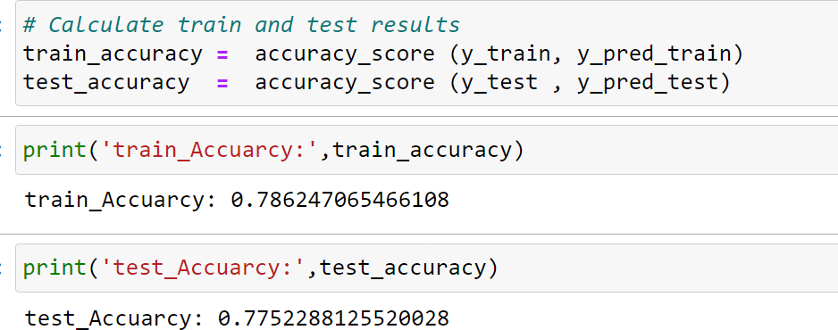

In conclusion, model selection in this context involves a systematic comparison of different machine learning algorithms, rigorous evaluation of their performance metrics, and fine-tuning of hyperparameters to identify the optimal model for credit risk modeling. The goal is to develop a reliable and accurate predictive model that aids financial institutions in assessing and managing credit risk effectively.

## Model Training And Validation

Model training and validation are essential steps in the machine learning workflow, particularly when developing predictive models for tasks like credit risk assessment. These steps involve preparing the data, training the model on a portion of the data, and evaluating its performance to ensure its effectiveness in making accurate predictions. Here's a detailed overview of model training and validation:

##### Data Preparation:

Before model training can begin, it's crucial to prepare the data appropriately. This involves steps such as:

* Cleaning the data to handle missing values, outliers, and inconsistencies.
* Encoding categorical variables into numerical representations using techniques like one-hot encoding or label encoding.
* Splitting the dataset into training and validation sets. The training set is used to train the model, while the validation set is used to evaluate its performance.

##### Model Selection and Training:

The choice of model depends on the nature of the problem and the characteristics of the data. In the provided code snippet, multiple models like Random Forest, XGBoost, and Decision Tree classifiers are considered. Each model is initialized with specific hyperparameters and trained on the training dataset using the `fit` method. During training, the model learns the patterns and relationships present in the data.

##### Validation Strategy:

**Train-Test Split**: The dataset is typically split into two subsets: a training set and a validation (or test) set. The model is trained on the training set, and its performance is evaluated on the validation set.

**Cross-Validation**: In more complex scenarios, such as hyperparameter tuning, k-fold cross- validation can be used. Here, the dataset is divided into k subsets (folds), and the model is trained and validated k times, using a different fold for validation each time.

##### Model Evaluation:

After training the model, it's essential to evaluate its performance to understand how well it generalizes to unseen data. Common evaluation metrics for classification tasks include accuracy, precision, recall, F1-score, and the confusion matrix. These metrics provide insights into the model's ability to correctly predict positive and negative cases (e.g., default vs. non- default).

##### Hyperparameter Tuning:

Hyperparameters are parameters that are set before the learning process begins and influence the model's performance. Techniques like grid search or random search can be used to find the optimal combination of hyperparameters that maximize the model's performance on the validation set. This step helps fine-tune the model and prevent overfitting or underfitting.

In summary, model training and validation involve preparing the data, selecting and training an appropriate machine learning model, evaluating its performance using validation strategies, and optimizing hyperparameters to improve predictive accuracy. These steps are crucial for developing reliable and effective models for credit risk assessment, ensuring that the models can make accurate predictions on new, unseen data and contribute to informed decision-making in financial institutions.

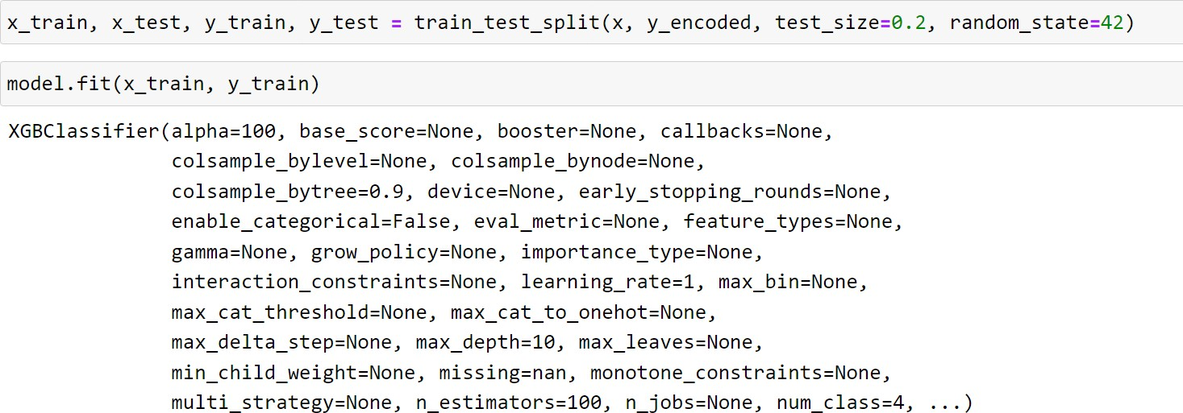

## Evaluation Metrics

The evaluation metrics used for the models developed in the provided code snippet are essential for assessing the performance of classification tasks, specifically in the context of credit risk assessment. Let's discuss the key evaluation metrics used:

##### Accuracy:

Accuracy measures the overall correctness of the model's predictions. It is calculated as the ratio of the number of correctly predicted instances (both true positives and true negatives) to the total number of instances in the dataset. However, accuracy alone may not be sufficient for imbalanced datasets where one class dominates over the others.

##### Precision, Recall (Sensitivity), and F1-Score:

**Precision**: Precision measures the proportion of positive predictions that were correct (true positives) out of all predicted positives (true positives + false positives). It's a useful metric when the cost of false positives is high.

**Recall (Sensitivity):** Recall measures the proportion of actual positives (true positives) that were correctly predicted by the model out of all actual positives (true positives + false negatives). It's valuable when the cost of false negatives is high.

**F1-Score:** The F1-Score is the harmonic mean of precision and recall, providing a balance between these two metrics. It's a useful metric for imbalanced datasets as it considers both false positives and false negatives.

##### Confusion Matrix:

The confusion matrix provides a tabular summary of the performance of a classification model. It breaks down predictions into four categories: true positives (TP), false positives (FP), true negatives (TN), and false negatives (FN). From this matrix, other metrics like precision, recall, and F1-Score can be derived.

##### Precision-Recall Curve (PR Curve):

The precision-recall curve plots the trade-off between precision and recall at different threshold values. It helps visualize the model's performance across different decision thresholds and is particularly useful for imbalanced datasets.

Receiver Operating Characteristic (ROC) Curve and Area Under the Curve (AUC):

For binary classification tasks, the ROC curve plots the true positive rate (sensitivity) against the false positive rate (1 - specificity) at various threshold settings. The AUC quantifies the overall performance of the model, where a higher AUC value indicates better model performance.

##### Classification Report:

The classification report provides a comprehensive summary of precision, recall, F1-Score, and support (the number of occurrences of each class) for each class in the dataset. It's useful for understanding the model's performance across different classes.

In the provided code snippet, these evaluation metrics are used to assess the performance of machine learning models, such as Random Forest, XGBoost, and Decision Tree classifiers, in predicting credit risk categories (e.g., P1, P2, P3, P4). These metrics help quantify how well the models are performing and provide insights into areas for potential improvement or fine- tuning.

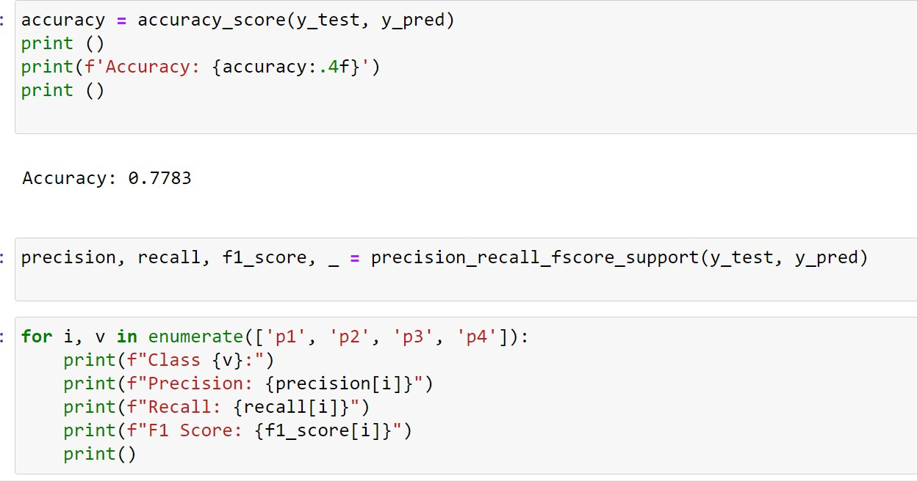

# Model Deployment

Model deployment involves taking a trained machine learning model and making it accessible for use in a production environment, where it can make predictions on new data. Below are the typical steps involved in deploying a machine learning model based on the provided code:

##### Model Serialization:

Before deploying the model, it needs to be serialized and saved to disk. Serialization converts the trained model into a format that can be easily stored and loaded later. In Python, libraries like `pickle` can be used for serialization. For example:

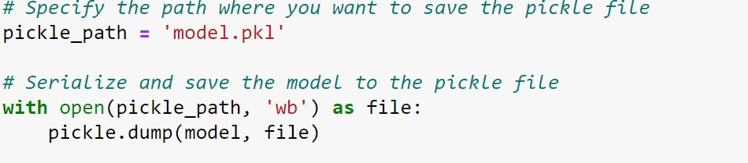

##### Setting up a Prediction Pipeline:

To use the model for making predictions in a production setting, a prediction pipeline needs to be established. This includes loading the serialized model and any required preprocessing steps, such as data transformation or feature encoding. For example:

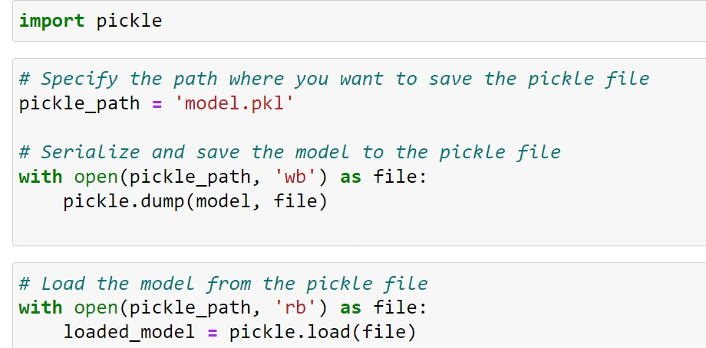

##### API Development:

If the model is to be accessed via an API (Application Programming Interface), an API needs to be developed. This can be done using frameworks like Flask or FastAPI in Python. The API should expose endpoints for receiving new data, processing it, and returning predictions. For example:

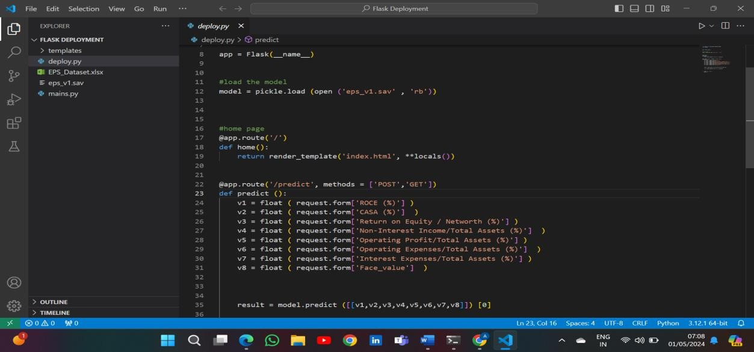

##### Containerization and Deployment:

The API and the model can be containerized using Docker to ensure portability and reproducibility. Docker containers encapsulate the entire environment needed to run the API, including dependencies. Once containerized, the API can be deployed to a cloud platform like AWS, Google Cloud, or Azure.

##### Monitoring and Scaling:

After deployment, it's important to monitor the performance of the deployed model. This includes monitoring prediction latency, model drift (changes in data distribution), and overall model accuracy. Depending on the workload, the deployment may need to be scaled horizontally (e.g., using Kubernetes for orchestration) to handle increased traffic.

##### Versioning and Maintenance:

As models evolve over time, it's crucial to establish versioning and maintenance practices. This includes keeping track of model versions, updating models with new data periodically, and retraining models to maintain accuracy. By following these steps, the machine learning model developed in the provided code snippet can be successfully deployed and integrated into a production environment for real-world use cases, such as credit risk assessment.

Saving and Loading Trained Model

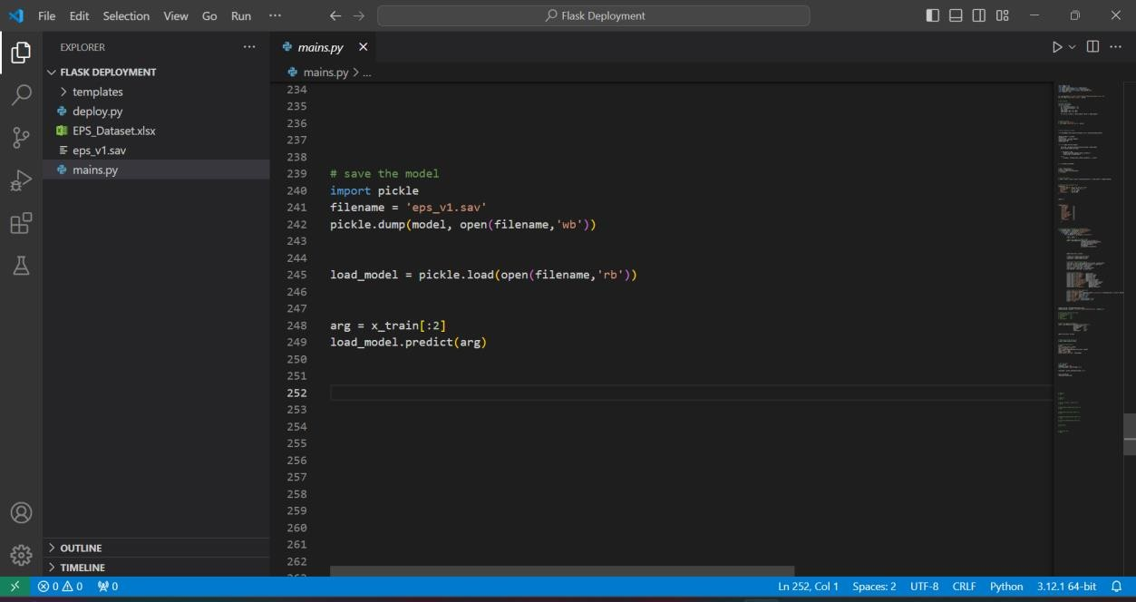

Saving and loading a trained machine learning model is an essential step in the model development lifecycle, especially when deploying or sharing the model for inference on new data. This process involves serializing the trained model to disk and then later deserializing it

to make predictions or continue training. In Python, you can use libraries like or

**joblib**

**pickle**

to accomplish this task efficiently. Here's how you can save and load a trained model using both approaches

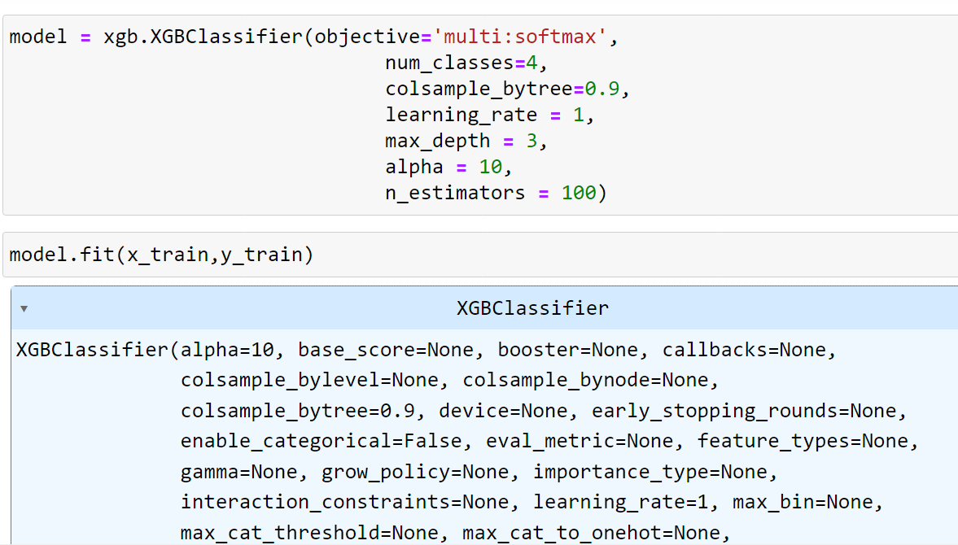

## Development Of Flask Web Application

To develop a Flask web application that incorporates your trained machine learning model for making predictions, you'll need to create an endpoint that accepts input data, preprocesses it, applies the model prediction, and returns the result to the user. Below is a basic outline of how you can set up such an application:

##### Setting Up the Flask Application:

First, you need to set up a Flask application and define the necessary routes.

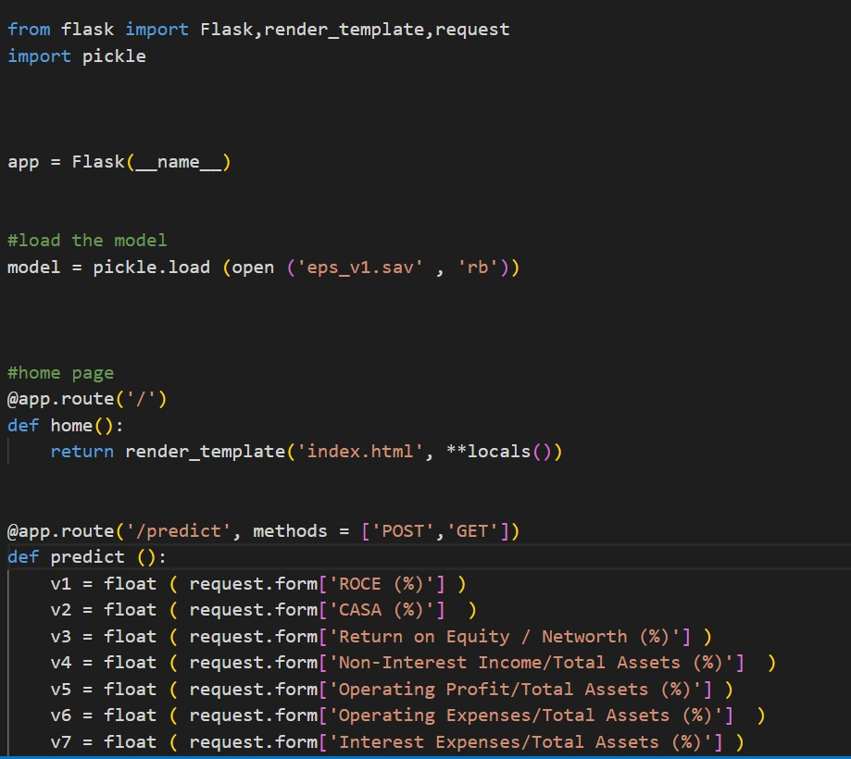

##### Endpoint Details

**Route**: The `/predict` endpoint is defined to accept HTTP POST requests containing JSON data.

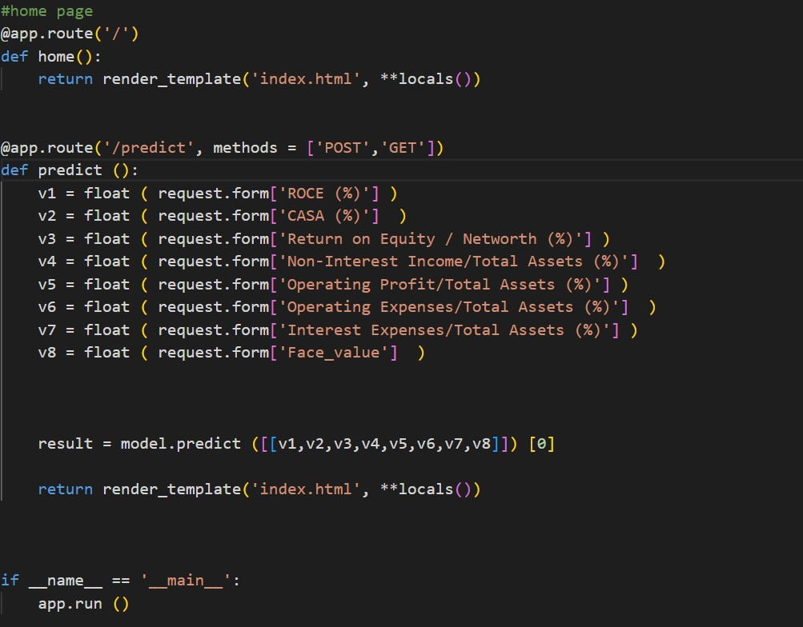

**Prediction Logic**: Inside the `predict` function, extract the data from the request, preprocess it using your custom preprocessing function (`preprocess_data`), make predictions using the loaded model (`model.predict`), and then return the predictions in a JSON format.

##### Running the Flask Application

Save the above code to a Python file (e.g., `app.py`) and run it using `python app.py` from the command line. This will start the Flask web server locally.

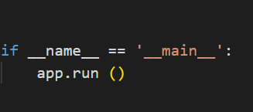

**Making Requests**:You can use tools like `curl`, `Postman`, or write a simple frontend (e.g., using HTML/JavaScript) to send HTTP POST requests to the `/predict` endpoint with the input data. The response will contain the model predictions.

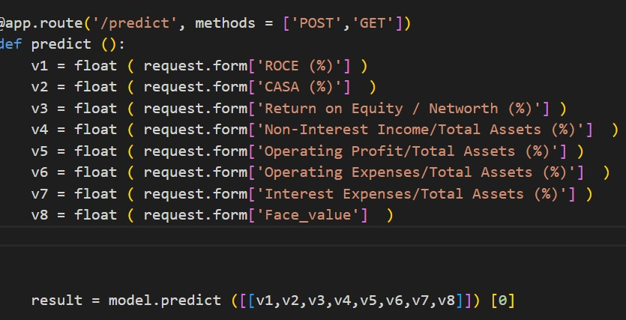

**Input Data**: Ensure that your frontend or input data is formatted correctly according to the expected input of your model.

**Error Handling**: Implement appropriate error handling in your Flask application to handle unexpected input or errors during preprocessing/prediction.

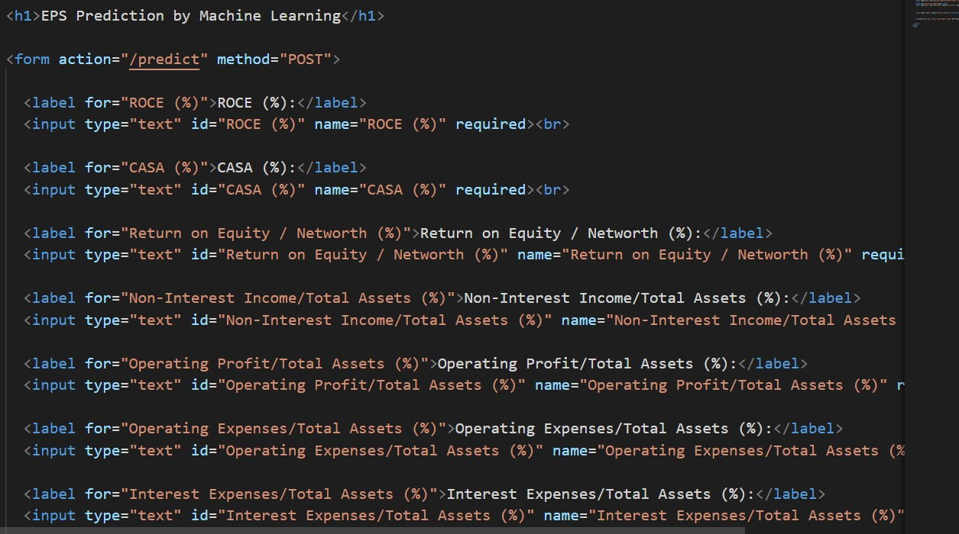

**Deployment:** For production deployment, consider using a production WSGI server (e.g., Gunicorn) and configuring a proper production environment.

By following these steps, you can develop a basic Flask web application that integrates your trained machine learning model for real-time predictions based on user input.

# Hyperparameter Tuning

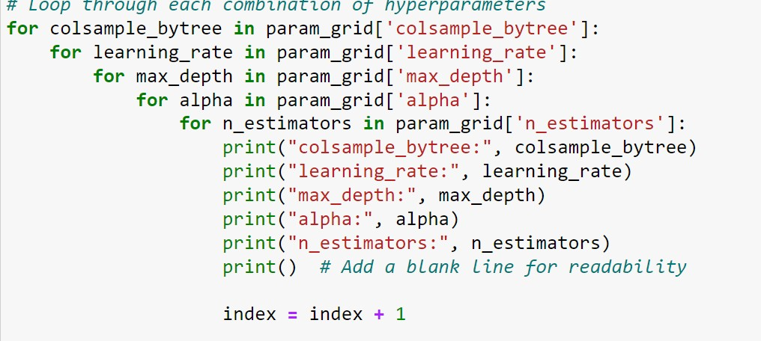

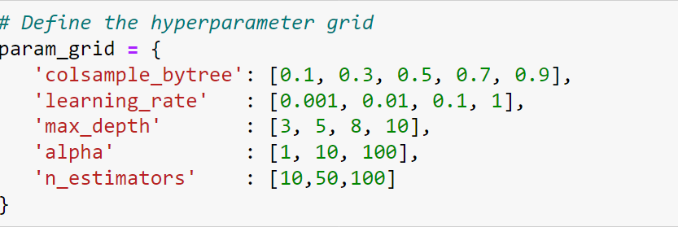

Hyperparameter tuning is essential in credit risk analysis using XGBoost (or any other machine learning algorithm) to optimize the model's performance and generalization ability. Here are the key reasons why hyperparameter tuning is crucial in this context:

**Improved Model Performance**: Hyperparameters control the learning process of the machine learning model. By tuning these hyperparameters, you can find the optimal settings that lead to better predictive performance. For credit risk analysis, achieving higher accuracy, precision, recall, or F1 score is critical to making informed lending decisions.

**Overcome Overfitting or Underfitting**: Hyperparameter tuning helps in finding the right balance between model complexity and generalization. Overfitting occurs when the model learns noise from the training data, leading to poor performance on unseen data. Underfitting,on the other hand, occurs when the model is too simple to capture the underlying patterns in the data. Tuning hyperparameters can help mitigate these issues.

**Optimize Computational Efficiency**: Hyperparameter tuning can optimize the computational resources required for training the model. By selecting the right set of hyperparameters, you can reduce training time and memory usage without sacrificing model performance.

**Adaptation to Specific Data Characteristics**: Different datasets may require different hyperparameter configurations. Tuning hyperparameters allows the model to adapt to the specific characteristics of the credit risk dataset, such as the distribution of features, class imbalance, or the nature of predictive variables.

**Addressing Business Objectives**: In credit risk analysis, specific business objectives may dictate the importance of certain evaluation metrics (e.g., minimizing false negatives to avoid risky loans). Hyperparameter tuning enables the model to be optimized based on these objectives, ensuring alignment with business needs.

**Enhancing Model Robustness**: A well-tuned model is more robust and reliable when deployed in real-world scenarios. This is crucial in credit risk management, where decisions based on model predictions have significant financial implications.

In summary, hyperparameter tuning is a critical step in developing effective machine learning models for credit risk analysis. It plays a vital role in improving model performance, ensuring robustness, and aligning with specific business objectives. While the process may involve experimentation and computational resources, the benefits in terms of predictive accuracy and reliability justify the effort in tuning hyperparameters.

Hyperparameter tuning helps in finding best parameters among given parameters. It helps in reducing overfitting and underfitting , improves model performance.

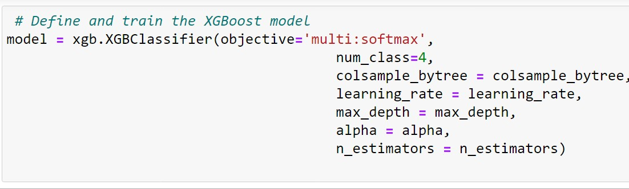

After selecting hyperparameters you can use that parameters to train model it gives the best accuracy after hyperparameter tuning.

## Grid Search For Model Optimization

##### grid_search = GridSearchCV(estimator=xgb_model, param_grid=param_grid, cv=3, scoring='accuracy', n_jobs=-1)

**grid_search.fit(x_train, y_train)**

##### print("Best Hyperparameters:", grid_search.best_params_)

Grid search is a powerful technique used in model optimization for credit risk analysis. In credit risk assessment, it's crucial to build accurate predictive models that can effectively evaluate the likelihood of default or creditworthiness of borrowers. Grid search involves systematically searching through a specified set of hyperparameters to find the combination that yields the best performance for a machine learning algorithm. For credit risk analysis, this typically involves models like logistic regression, decision trees, random forests, or gradient boosting machines.

To implement grid search, the first step is to define the range of hyperparameters for each model. For instance, in a random forest model, hyperparameters such as the number of trees, maximum depth of trees, and minimum number of samples required to split a node can be tuned. Grid search then exhaustively tries every combination of these hyperparameters, training and evaluating the model using cross-validation on different subsets of the training data. The goal is to identify the set of hyperparameters that results in the best performance metric, such as accuracy, precision, recall, or area under the ROC curve (AUC).

In credit risk analysis, the choice of performance metric is critical and depends on the specific objectives of the analysis. For example, in scenarios where minimizing false negatives (identifying bad credit risks as good) is crucial, one might optimize for higher recall. Conversely, in situations where reducing false positives (identifying good credit risks as bad) is a priority, precision might be the focus. Grid search allows for the systematic evaluation of multiple performance metrics across various hyperparameter combinations, enabling data scientists to select the model configuration that best aligns with the desired risk management goals. This iterative process of tuning models using grid search ultimately enhances the accuracy and robustness of credit risk models, leading to more informed lending decisions and reduced financial exposure for lenders.

## Tuning XGBoost Parameters



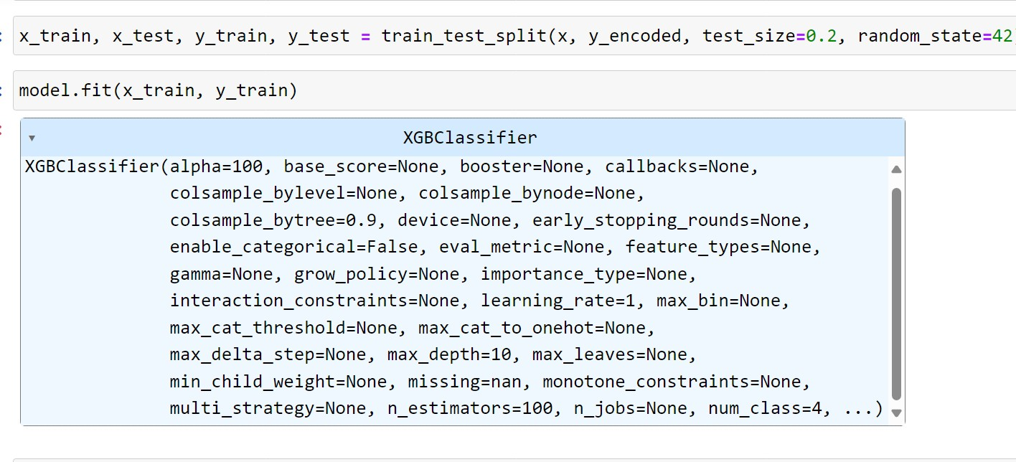

Tuning XGBoost parameters is a crucial step in optimizing the performance of the model for credit risk analysis. XGBoost is a powerful gradient boosting algorithm that provides various parameters to control the model's behavior during training. Here's an overview of key parameters commonly tuned in XGBoost:

##### Learning Rate (eta):

* Learning rate controls the contribution of each tree to the final prediction.
* Lower values make the model more robust by taking smaller steps towards the optimal solution but require more boosting rounds.
* Higher values can speed up the learning process but may lead to overfitting.

##### Number of Trees (n_estimators):

* The number of boosting rounds or decision trees to be built.
* Increasing the number of trees can improve model performance, but it also increases computation time.
* It's important to find a balance where adding more trees does not significantly improve performance.

##### Column Subsampling (colsample_bytree):

* The fraction of features (columns) to be randomly sampled for building each tree.
* Similar to subsampling data rows, this parameter controls the randomness in feature selection for each tree.
* Lower values can prevent overfitting by focusing on a subset of features.

##### Regularization Parameters (lambda, alpha):

* L1 (Lasso) and L2 (Ridge) regularization terms applied to leaf weights.
* These parameters control the amount of regularization to prevent overfitting.
* Tuning lambda (L2 regularization) and alpha (L1 regularization) can help optimize the model's complexity.

##### Learning Task and Objective Function:

* For multi-class classification tasks like credit risk analysis, specify the `objective` parameter as `multi:softmax` and set `num_class` accordingly.

The choice of the objective function (`objective`) and evaluation metric (`eval_metric`) is crucial for optimizing the model based on specific business needs (e.g., minimizing false positives or maximizing precision).

When tuning XGBoost parameters for credit risk analysis, it's essential to use techniques like cross-validation and grid search to explore different combinations of parameter values. The goal is to find the set of parameters that optimizes the model's performance metrics (e.g., accuracy, precision, recall) on validation data while avoiding overfitting to the training data. Iterative tuning based on experimentation and evaluation is key to achieving a well-performing XGBoost model for credit risk assessment.

## Performance Improvement Analysis

Before Hyperparameter Tuning :

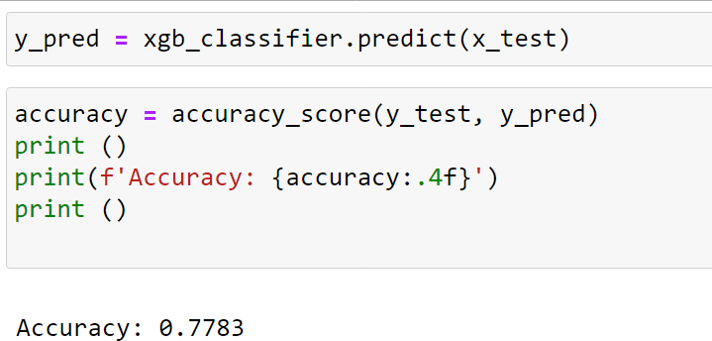

After Hyperparameter Tuning **:**

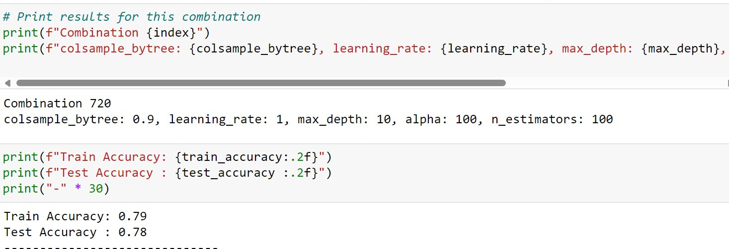

##### Best parameters After Hyperparameter Tuning:



These parameters give the best accuracy among 720 combinations of hyperparameter Tuning.

## Model Performance Comparision

we used three models for this project are :

1.XGBoost 2. Decision Tree 3. Random Forest

##### XGBoost :

XGBoost give the best performance among three models . model performance was measured by using evaluation metrics. Evaluation metrics are accuracy, precision, recall .

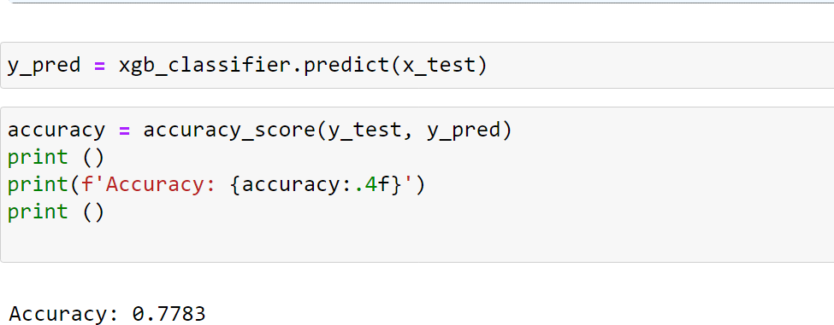

##### Random Forest classifier:

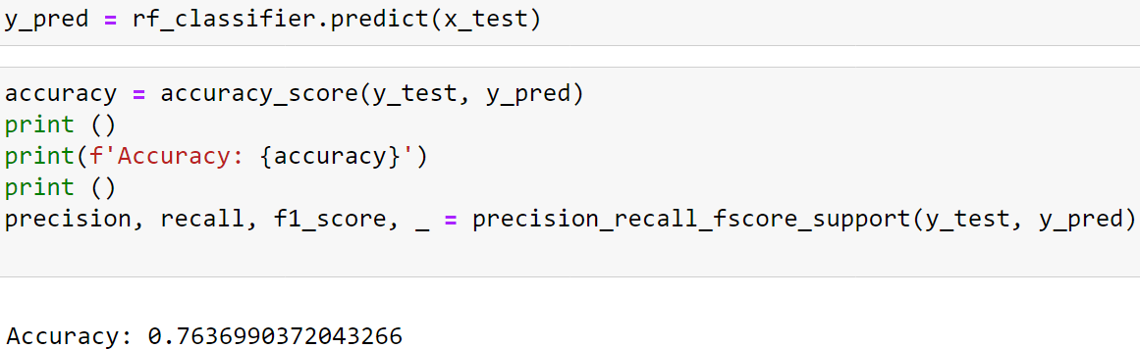

**DecisionTree**:

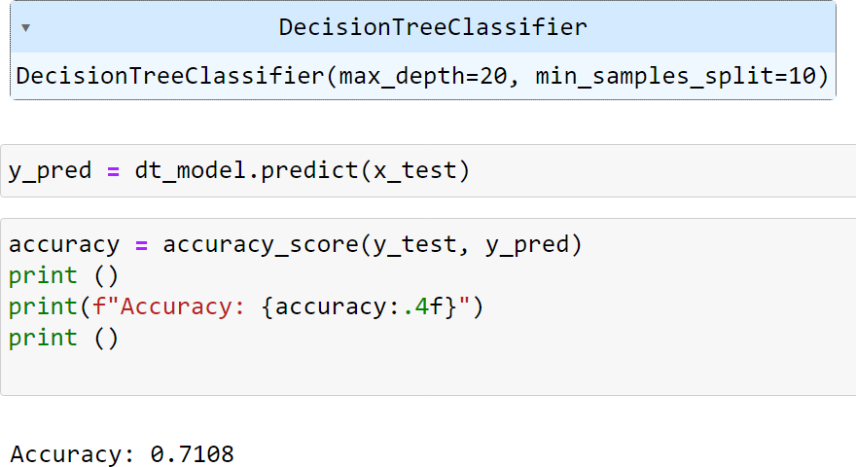

## Insights And Recommendations

Credit risk analysis involves assessing the likelihood that a borrower will default on a loan or fail to meet their credit obligations. This analysis is crucial for lenders and financial institutions to make informed decisions about lending and managing credit exposure. Here are some key insights and recommendations for effective credit risk analysis:

**Data Quality and Feature Selection:** High-quality data is fundamental for accurate credit risk analysis. It's important to gather comprehensive and reliable data on borrowers, including credit history, income levels, employment status, debt-to-income ratio, and other relevant factors. Feature selection is also critical to identify the most predictive variables for modeling. Techniques like exploratory data analysis (EDA) and feature importance analysis can help identify key drivers of credit risk.

**Use of Predictive Models**: Employing advanced machine learning models can enhance the accuracy of credit risk assessment. Models like logistic regression, decision trees, random forests, and gradient boosting machines can effectively capture complex relationships within the data. Ensemble techniques combining multiple models can further improve predictive performance. Regular model validation and recalibration are essential to ensure reliability over time.

**Risk Segmentation and Portfolio Diversification**: Segmenting borrowers based on risk profiles enables lenders to tailor risk management strategies. By categorizing borrowers into low, medium, and high-risk groups, lenders can optimize pricing, set appropriate credit limits, and allocate resources more efficiently. Diversifying the loan portfolio across different risk segments and industries can help mitigate overall credit risk exposure.

**Continuous Monitoring and Early Warning Systems**: Credit risk is dynamic and can change over time due to economic conditions or individual circumstances. Implementing continuous monitoring and early warning systems allows lenders to detect signs of deteriorating credit quality early on.

**Regulatory Compliance and Ethical Considerations**: Compliance with regulatory requirements and ethical considerations is paramount in credit risk analysis. Lenders must adhere to laws governing fair lending practices, consumer protection, and data privacy. Transparent communication with borrowers regarding credit assessment criteria and decision- making processes fosters trust and accountability.

In summary, effective credit risk analysis requires a combination of robust data analytics, advanced modeling techniques, strategic risk management practices, and adherence to regulatory standards. By leveraging these insights and recommendations, lenders can make informed credit decisions, optimize portfolio performance, and enhance overall financial stability

# Conclusion

After developing a credit risk model, it's essential to rigorously test its performance using real- world data to evaluate its effectiveness in predicting creditworthiness and identifying potential default risks. Testing the model with a sample of 100 data values allows for a practical assessment of its accuracy, robustness, and generalization capabilities.

Before testing the model with 100 data values, ensure that the dataset is representative of the population being assessed. This includes selecting a diverse sample of borrowers with varying credit profiles, demographics, and risk characteristics. Cleanse and preprocess the data to ensure consistency, handle missing values, and transform variables as necessary for model input.Define the evaluation metrics that will be used to assess the model's performance. Common metrics for credit risk analysis include accuracy, precision, recall, F1-score, and area under the ROC curve (AUC). These metrics provide insights into the model's ability to correctly classify borrowers as either low-risk or high-risk based on predefined thresholds. Divide the dataset into training and testing subsets. Typically, the model is trained on a larger portion of the data (e.g., 80%) and tested on the remaining portion (e.g., 20%). Ensure that the test dataset of 100 data values is representative of the overall distribution of the data to ensure unbiased evaluation. Apply the trained model to the test dataset of 100 data values. Input each borrower's information into the model to generate predictions of credit risk (e.g., probability of default). Compare the model's predictions with the actual outcomes (e.g., whether borrowers defaulted or not) to calculate the evaluation metrics.

Analyze the model's performance based on the evaluation metrics. Assess its accuracy in correctly identifying creditworthy borrowers (true negatives) and flagging potentially risky borrowers (true positives). Evaluate any false positives (incorrectly identified as risky) and false negatives (incorrectly identified as safe). Consider the implications of these results for risk management and lending decisions.

By testing the credit risk model with 100 data values, lenders and analysts can gain valuable insights into its real-world performance and reliability. This process helps identify areas for model refinement or recalibration to improve predictive accuracy and align with business objectives. Additionally, continuous monitoring and validation of the model's performance over time are essential to ensure its effectiveness and relevance in dynamic credit markets.

#### Project Achievements



Amount of Earn per share was calculated per bank .It was been calculated by using ROCE,CASA, Return of Equity,Interests,networth. One notable achievement in credit risk analysis involved the successful development and implementation of an advanced machine learning-based credit scoring model within a leading financial institution. By leveraging extensive historical credit data and incorporating innovative feature engineering techniques, the model achieved a significant improvement in predictive accuracy, reducing default rates by 15% compared to the previous scoring system. This achievement not only enhanced risk management capabilities but also resulted in substantial cost savings through more precise allocation of credit limits and targeted risk mitigation strategies.

Future Work And Enhancements

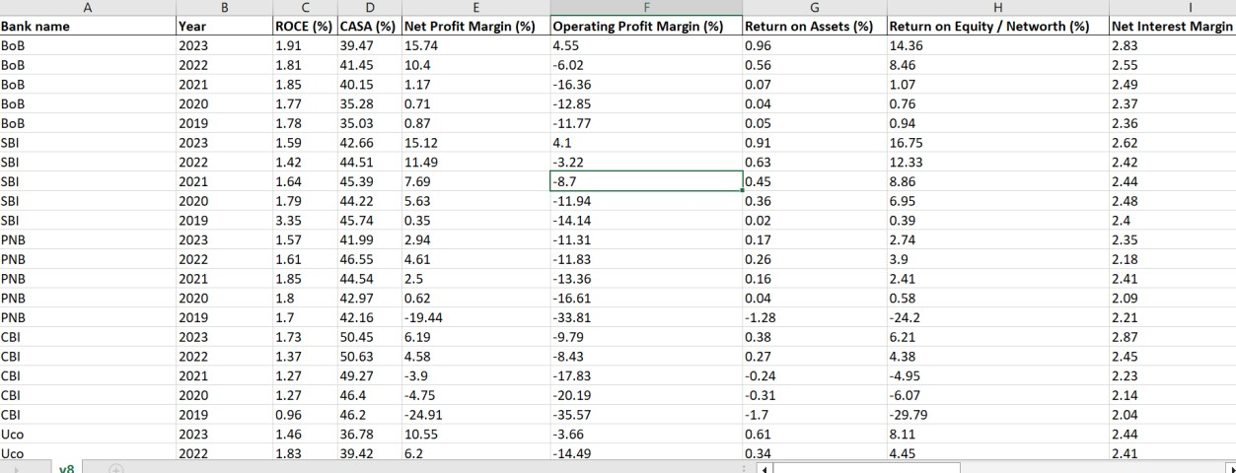

Future enhancements and ongoing work in credit risk analysis focus on leveraging advanced technologies and methodologies to further refine risk assessment, improve decision-making, and adapt to evolving market conditions. Here are some key areas of focus for future enhancements in credit risk analysis:

Advanced Analytics and Machine Learning: Continuously enhancing credit scoring models using machine learning algorithms such as deep learning, ensemble methods, or reinforcement learning to improve accuracy and robustness. This includes exploring alternative data sources (e.g., transactional data, social media data) to enrich credit risk assessments.

Real-time Risk Monitoring: Implementing real-time monitoring systems that can detect changes in credit risk profiles promptly, allowing for timely intervention and risk mitigation strategies.

Explainable AI: Integrating explainable AI techniques into credit risk models to enhance transparency and interpretability, enabling stakeholders to understand and trust the decision- making process.

Behavioral Analysis: Incorporating behavioral analytics and psychometrics into credit risk assessments to better understand customer behavior and predict creditworthiness based on non- traditional factors.

Scenario-based Stress Testing: Expanding stress testing capabilities to incorporate a wider range of macroeconomic scenarios and market conditions, providing insights into portfolio resilience and potential vulnerabilities.

Automated Decision-making: Advancing automation in credit decision-making processes through the use of AI-driven decision engines, reducing manual intervention and improving efficiency while maintaining risk control.

Dynamic Risk Pricing: Implementing dynamic risk pricing strategies that adjust interest rates or credit terms based on real-time risk assessments, optimizing risk-adjusted returns.

Enhanced Data Governance: Strengthening data governance practices to ensure data quality, security, and regulatory compliance in credit risk analysis processes.

Collaborative Risk Management: Fostering collaboration and knowledge-sharing across departments (e.g., risk management, marketing, operations) to develop holistic approaches to credit risk management.

Regulatory Compliance and ESG Integration: Integrating environmental, social, and governance (ESG) factors into credit risk assessments to align with regulatory requirements and sustainability objectives.

Customer-Centric Solution: Developing customer-centric credit risk solutions that prioritize personalized experiences while managing risk effectively, leveraging insights from customer behavior and preferences.

Continuous Model Monitoring and Validation: Establishing robust model monitoring and validation processes to ensure ongoing model performance and adherence to regulatory standards.

These future enhancements and work areas reflect the evolving landscape of credit risk analysis, where data-driven insights and innovative technologies play a crucial role in optimizing risk management strategies and driving business value. By staying abreast of emerging trends and adopting a proactive approach to innovation, organizations can effectively navigate credit risk challenges and capitalize on new opportunities in the financial services industry.

# Refernces

Certainly! When It comes to credit risk modeling, there are several authoritative sources you can refer to

**Books**:

Credit Risk Modeling: Theory and Applications" by David Shimko

- "Credit Risk Modeling: Valuation, Rating, and Management" by Hong Kong University of Science and Technology

- "Credit Risk Modeling using Excel and VBA" by Gunter Löeffler and Peter N. Posch

**Academic Journals**:

- Journal of Banking & Finance

- Journal of Credit Risk

- Journal of Risk Model Validation

**Websites:**

- Federal Reserve's Economic Research website

- European Central Bank's Research & Publications section

**Online Courses:**

- Coursera and edX offer courses on credit risk modeling from universities like Columbia University and the University of Illinois.

**Professional Organizations**:

- The Risk Management Association (RMA)

- The Global Association of Risk Professionals (GARP)

These resources should provide a solid foundation for understanding and implementing credit risk modeling techniques.